**SAP BW/BO Exercise**

**HANA Cube Data Modeling**

**Note: You must use the following conventions to name objects/systems created in this exercise.**

**Replace S with the semester**

**A for Fall**

**B for Spring**

**C for Summer**

**Replace XX with the two character year (ex. 20 for 2020)**

**Replace YYY with your Student ID (ex. 147 if you were issued ID GBI_147)**

**Please use the screenshots ONLY as a reference. The instructions have to be followed AS-IS.**

Objective

In the previous exercise we created customer and product dimension view. In this exercise we will be combining these dimension views (dimension) with sales (fact) and form an cube view (Info cube). Also, we will do some reporting on the view.

You may need SAP LUMIRA for this assignment.

Installation: Download SAP Lumira from the elearnig. Double click on .exe file and it will open SAP LUMIRA Self-extracting archive.

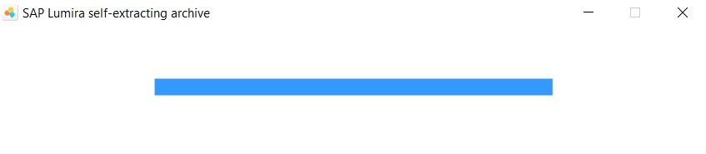

After it is extracted installation manager opens.

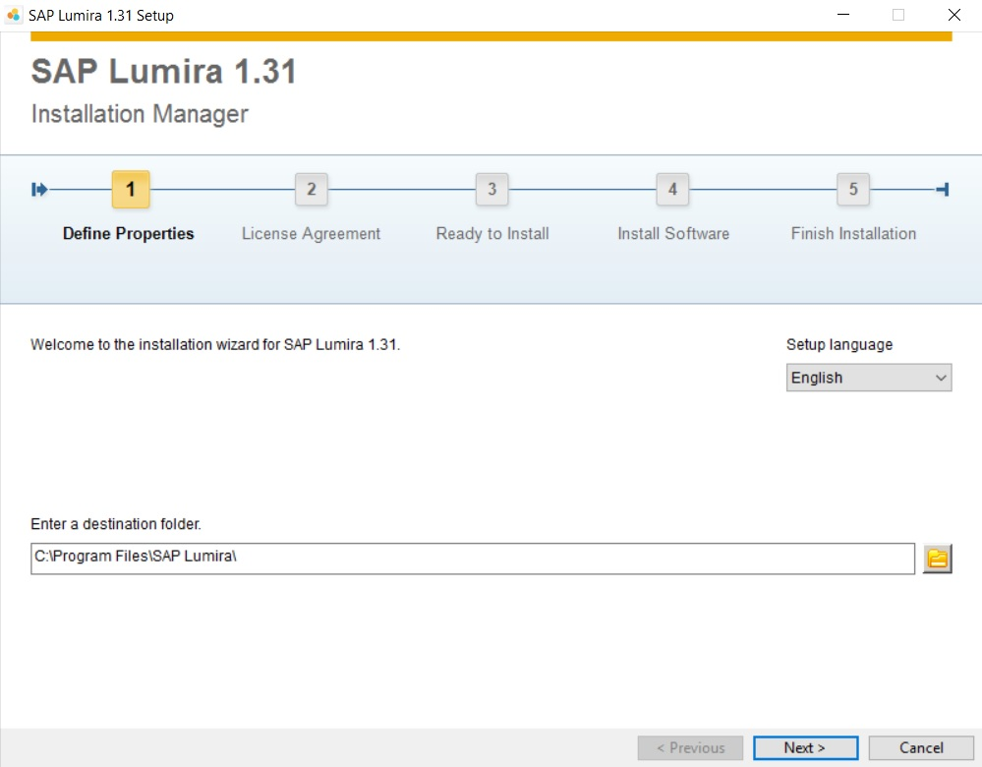

Click Next -> Check the “I accept the License Agreement” checkbox and click Next -> Click Next.

Installation will start. 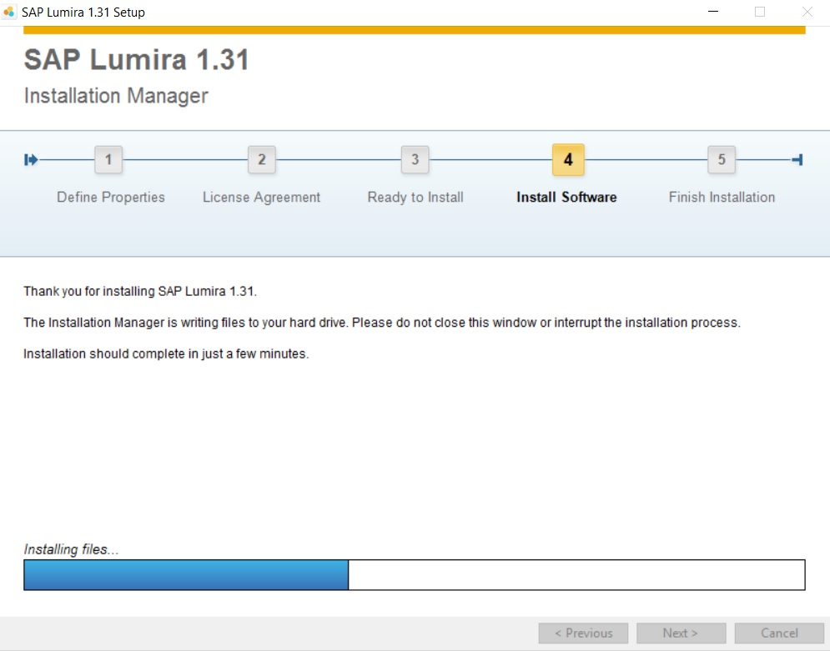

After it is complete, click Finish. Open SAP LUMIRA. A prompt window to enter keycode pops up.

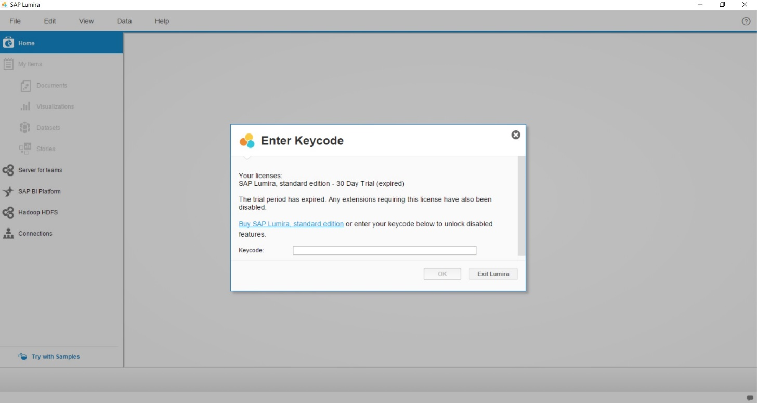

Enter the Keycode provided on Elearning and click OK.

1. Create an cube view

You want to analyze the sales data by customer and product.

Therefore, you create a simple star schema that includes facts from your sales table. The customer dimension view and product dimension view will represent the dimensions in the star schema.

The star schema is shown in the figure below.

Sales data table

SALES_***YYY***

Customer dimension view

CUSTOMER_ATV_***YYY***

Product dimension view

PRODUCT_ATV_***YYY***

* 1. Create a new cube view for the sales data in your package

Use following details to create the view:

**Package name**: GBI_YYY

**View name**: SALES_AV_**YYY**

**View description**: Sales **YYY**

**Tables:** SALES_**YYY**

**Views:** CUSTOMER_ATV_**YYY**PRODUCT_ATV_**YYY**

Steps:

1. Go to the Editor page.

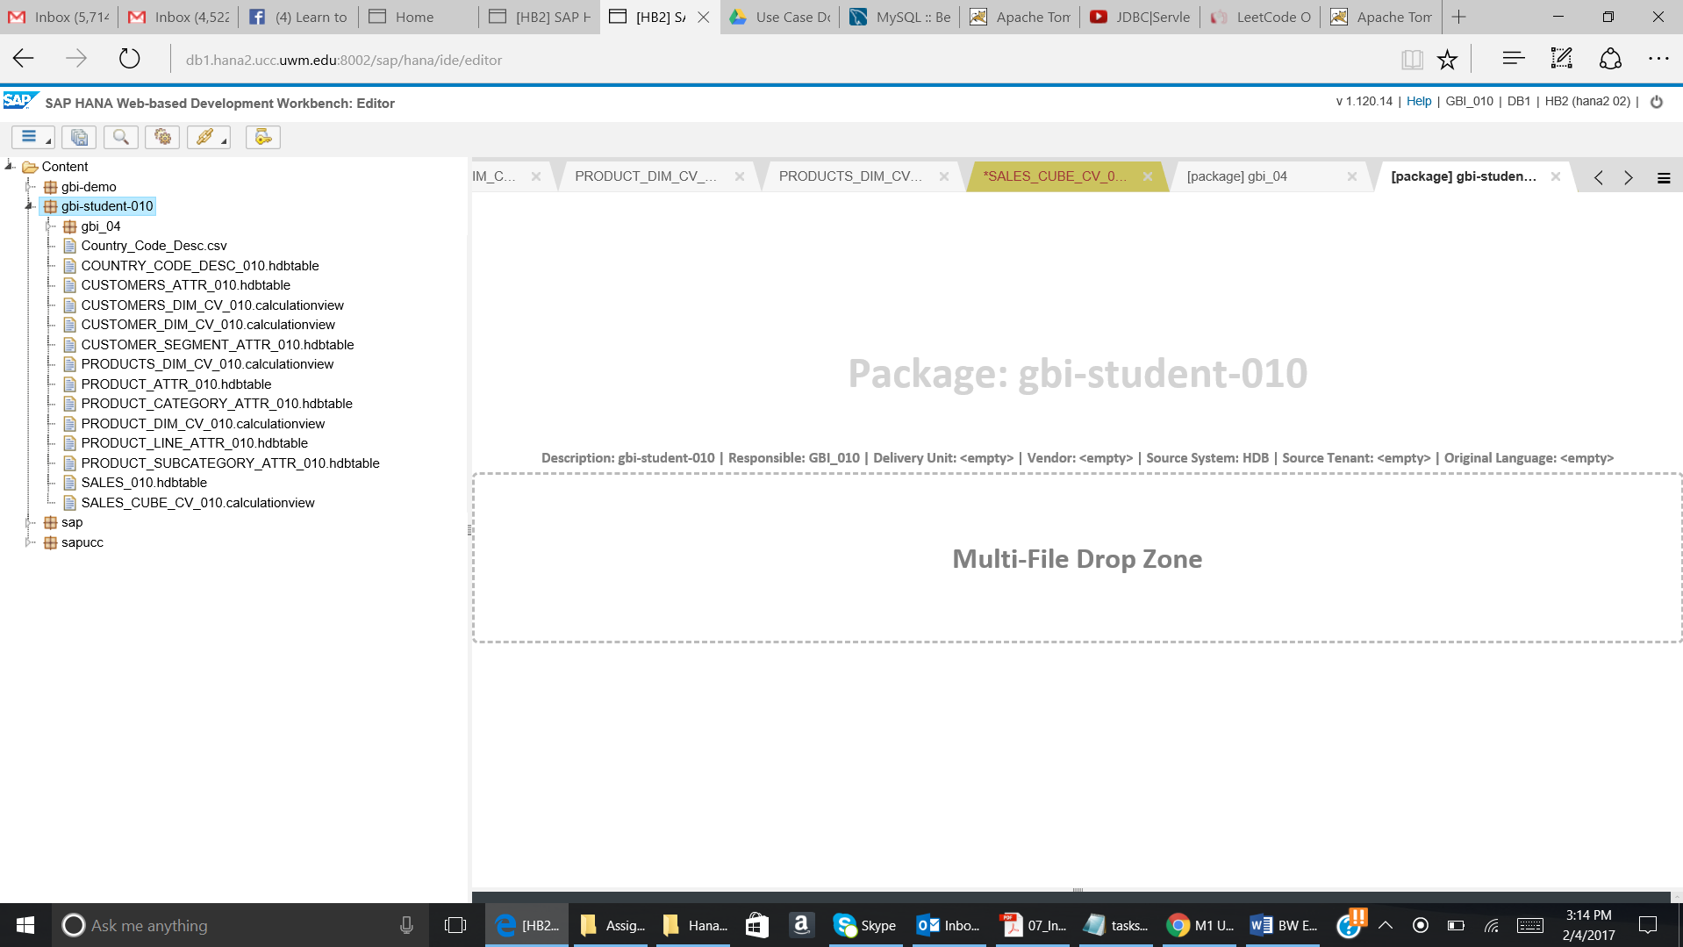

1. Right click on GBI_YYY. Click on New and then select Calculation View.

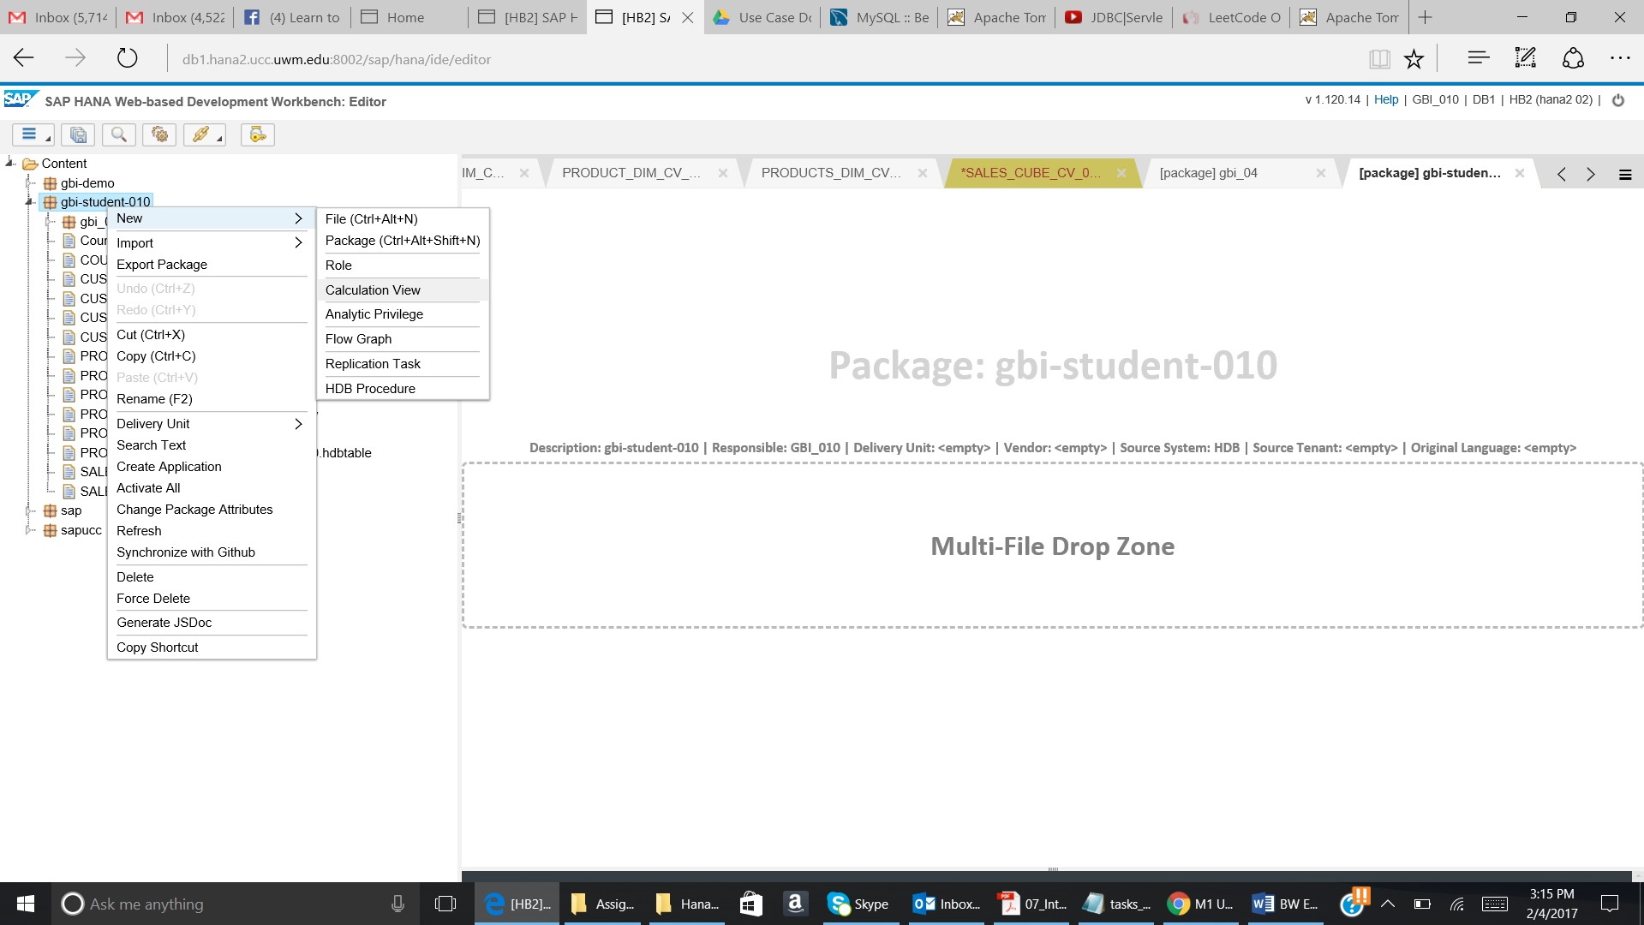

The below given pop up will come. Enter the values in the pop up as given below:

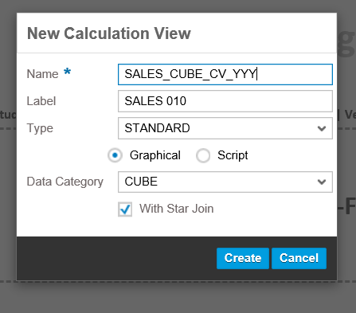

Don’t forget to select the With **Star Join.**

1. The below given screen will come:

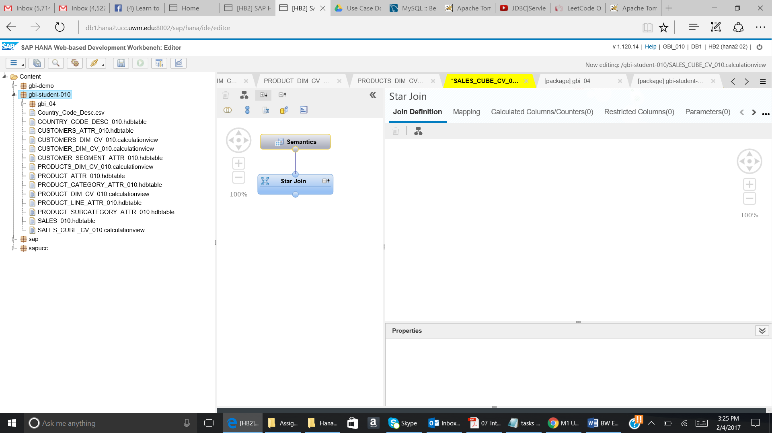

Drag a projection on to the canvas.

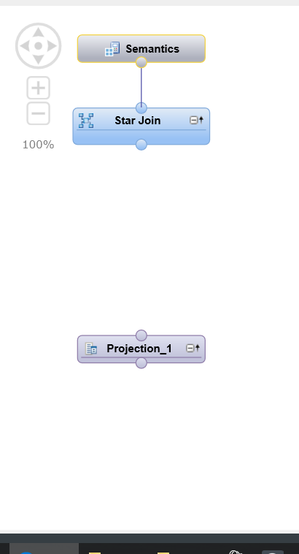

Now click on Projection_1 and + sign will appear. Click on the + sign to add Sales_YYY table.

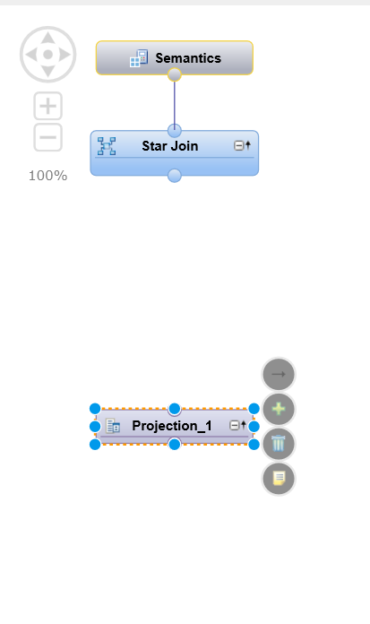

When we click on the + sign then the above given pop up will come. Search for Sales_YYY table. The Sales_YYY table will appear in the search result. Select the table and click on OK.

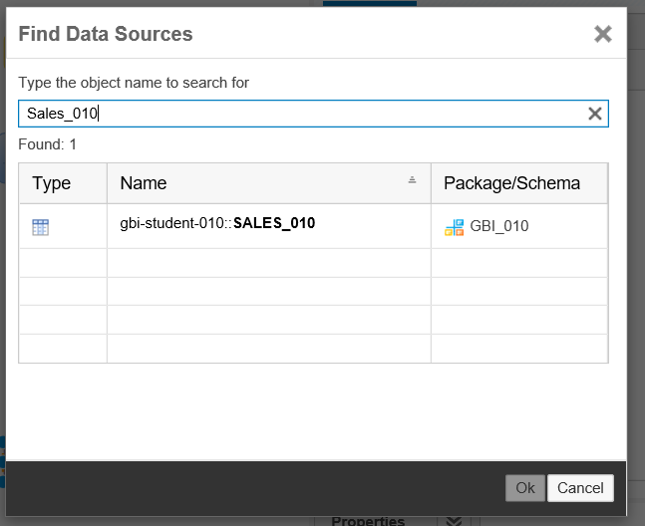

The projection will look as given below:

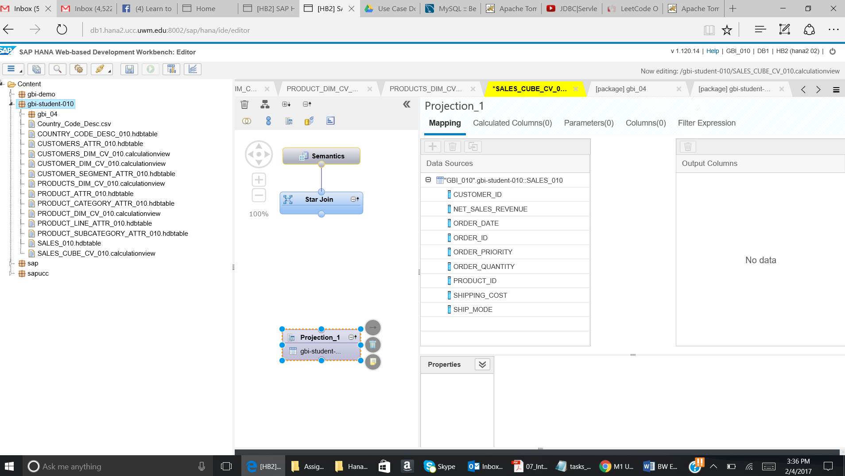

Map all the columns to the Output columns.

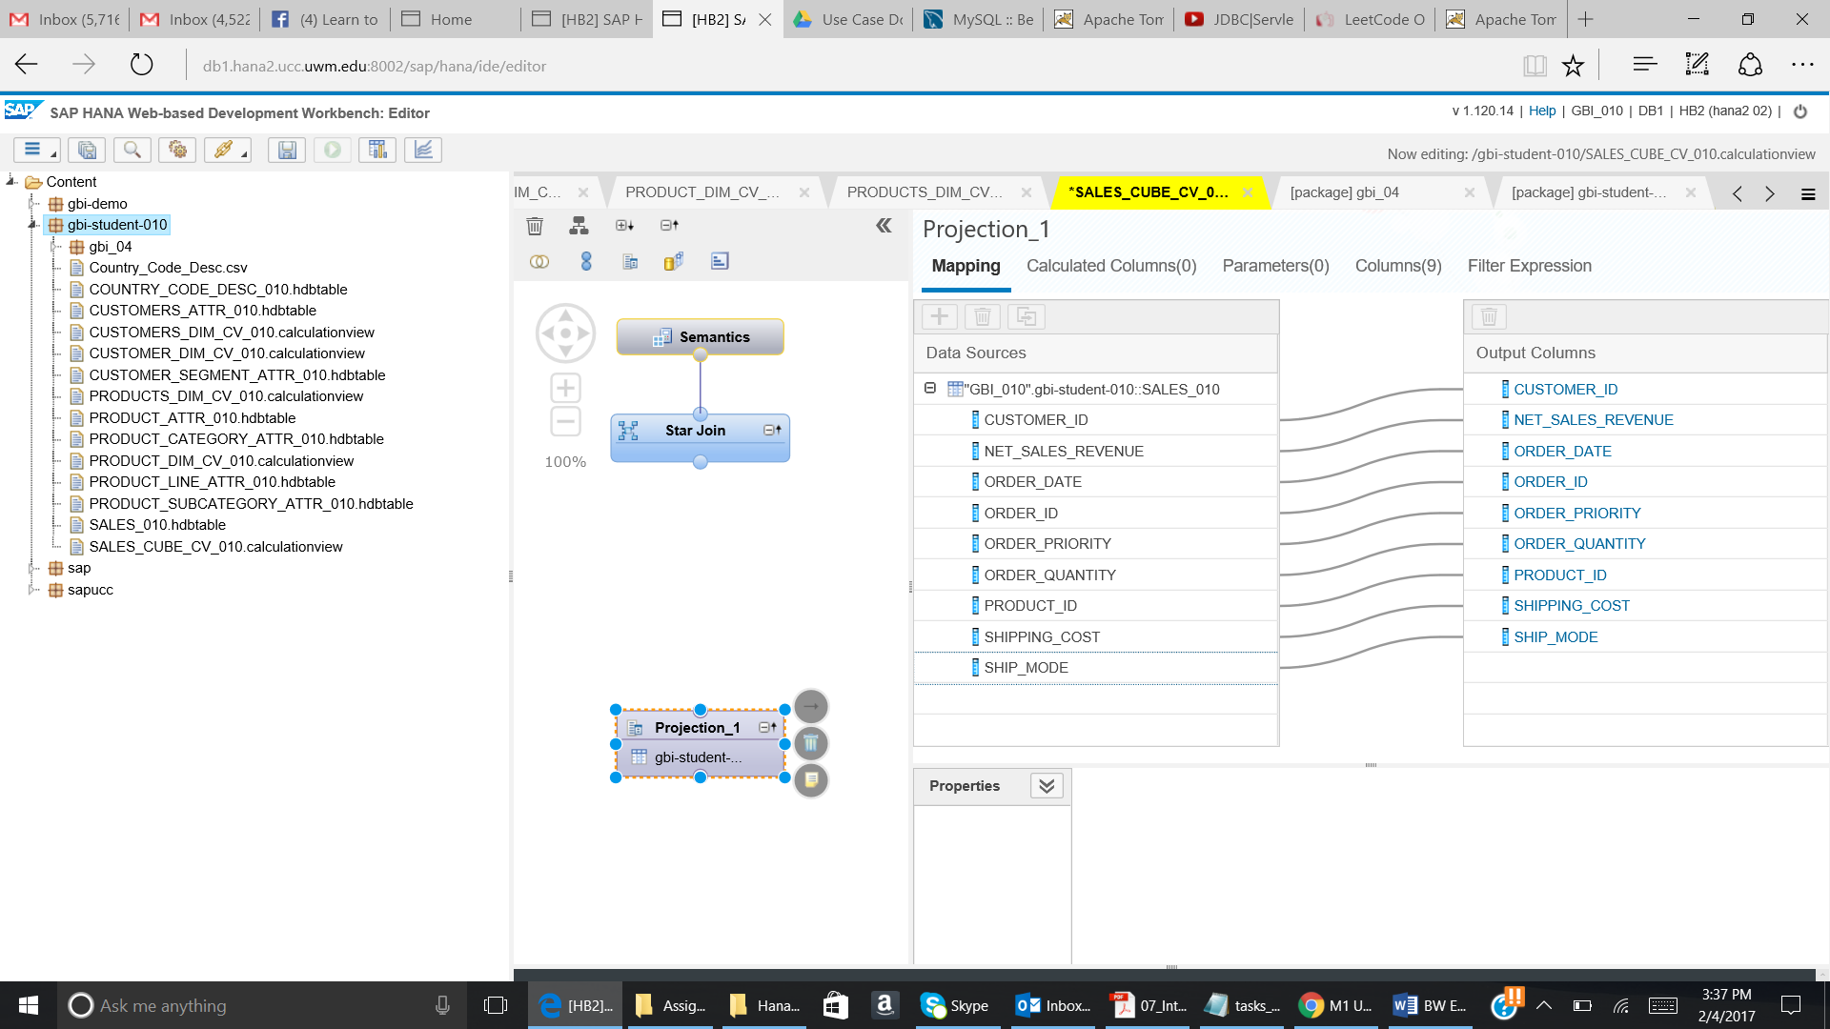

1. Now add a Join.

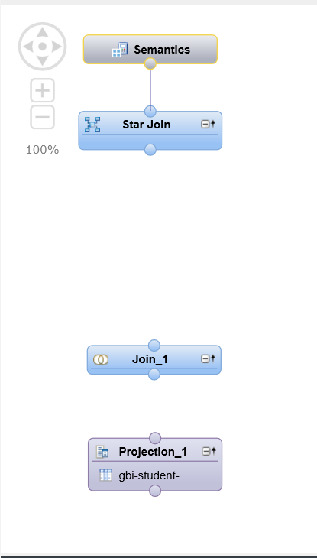

Now join the Projection_1 to the Join_1.

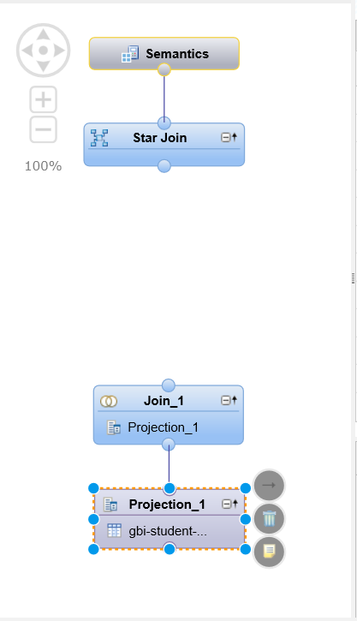

Now add the table M_TIME_DIMENSION into the Join_1 condition.

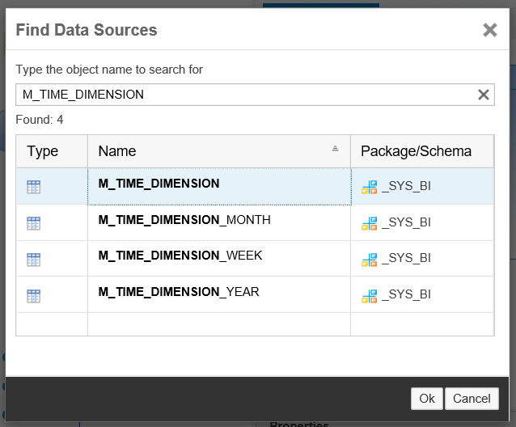

Select the M_Time_Dimension table and click on OK. The table will be added into the Join_1.

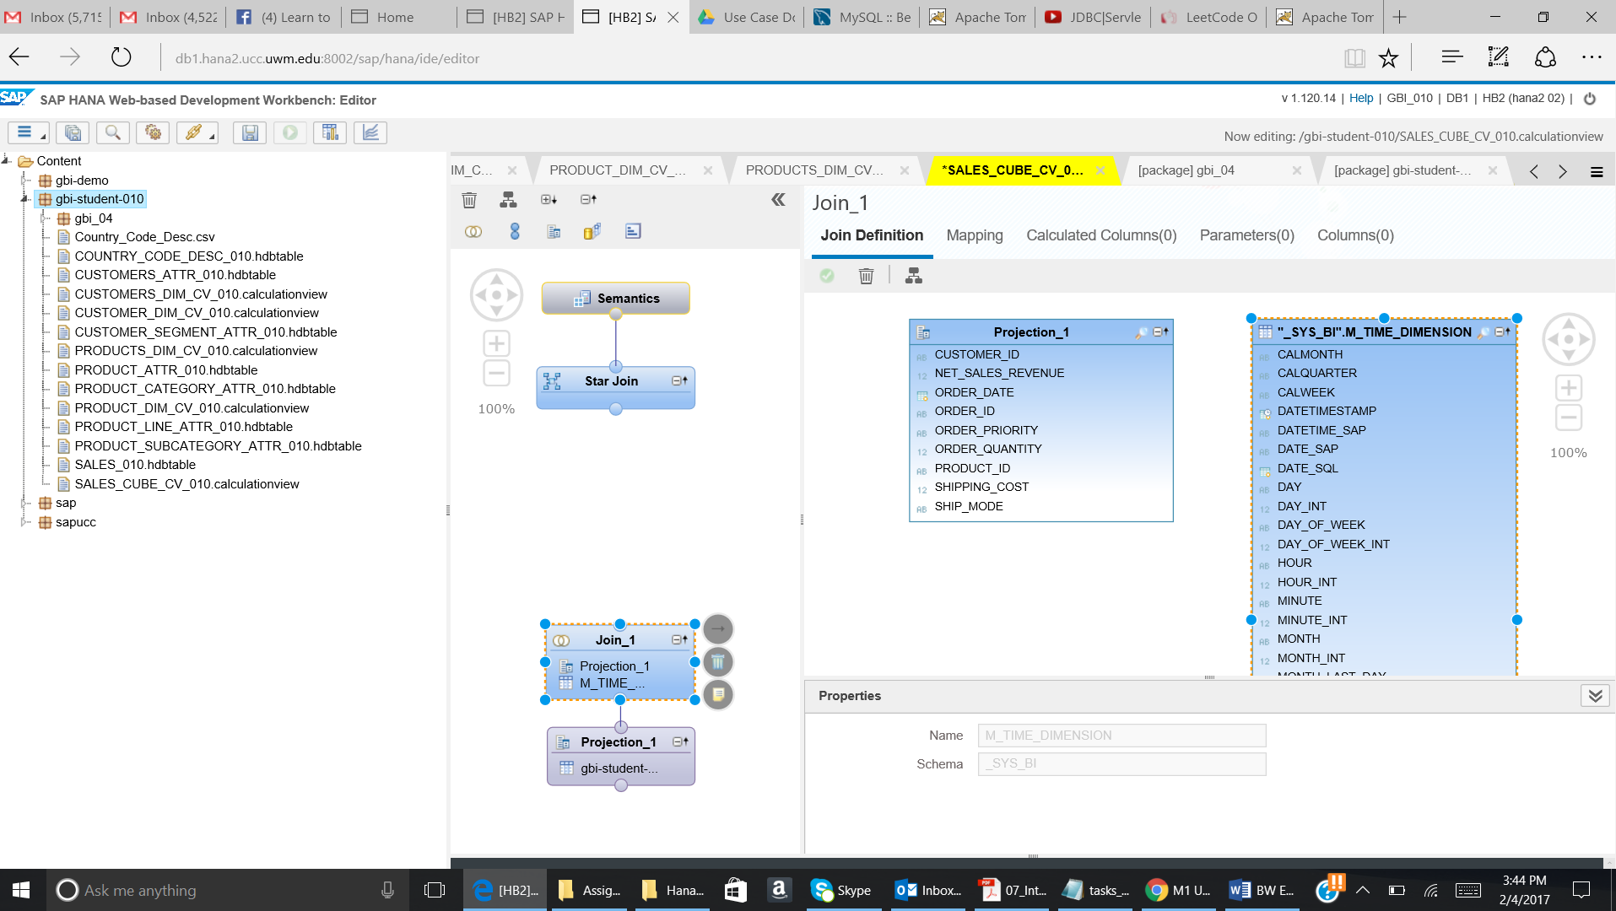

Join the Order_Date on Projection_1 to the Date_Sql of the M_Time_Dimension.

**Ensure the Cardinality is 1:1**

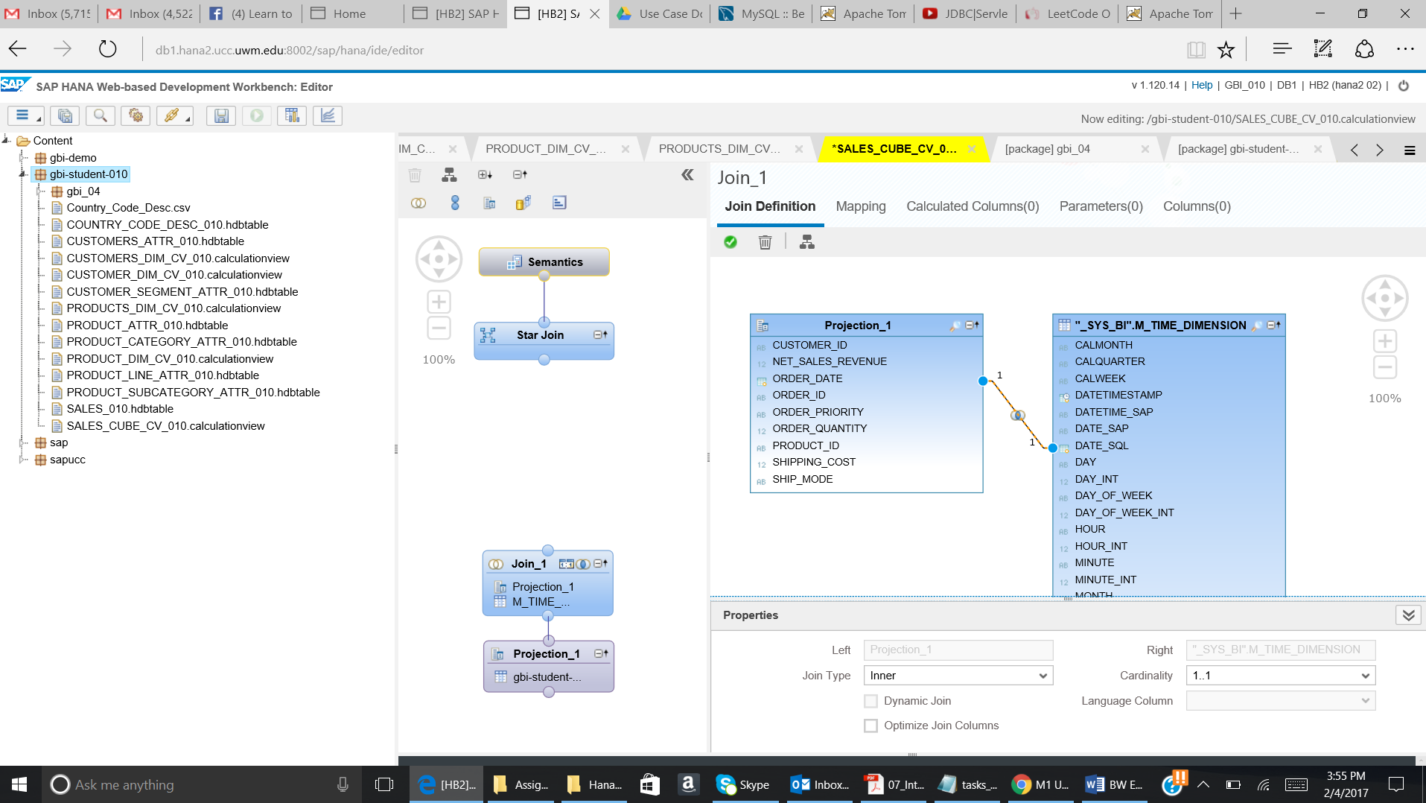

Now go to the mapping tab and perform the mapping as given below:

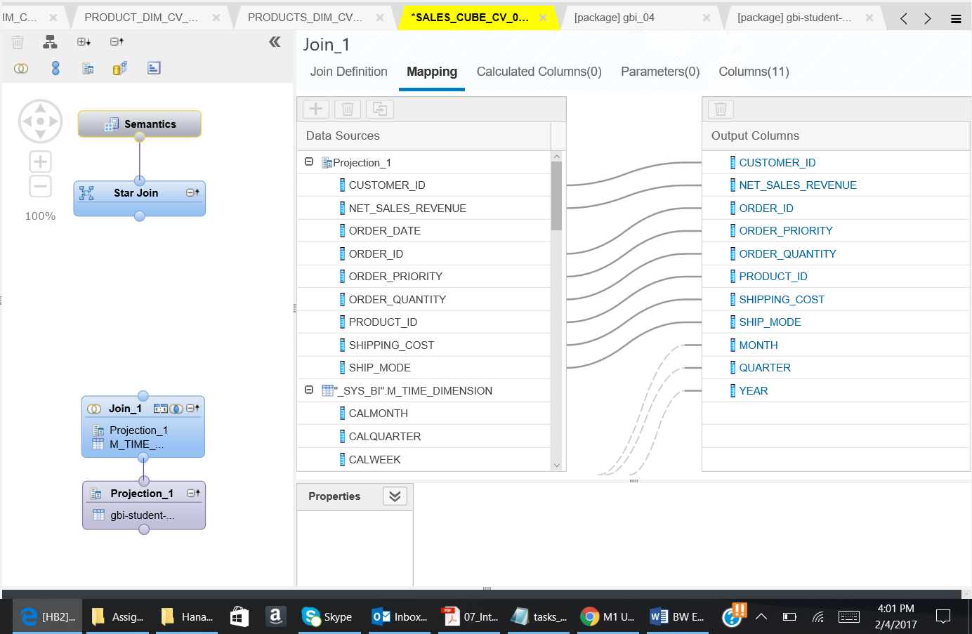

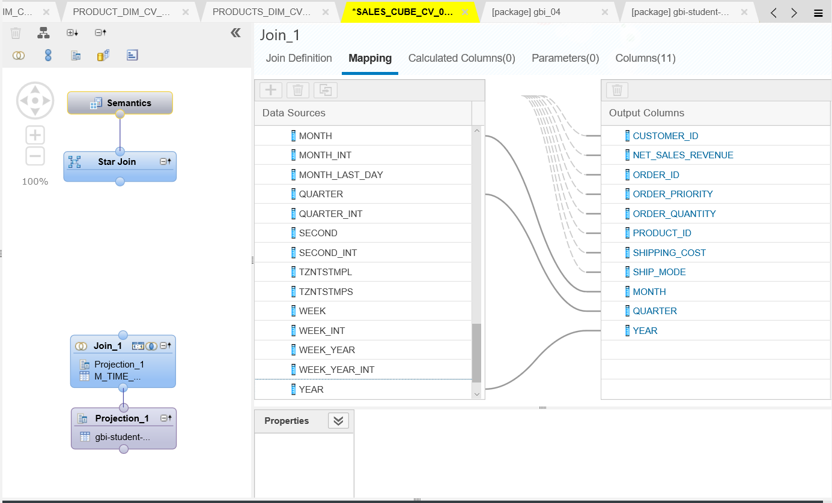

The columns should look as given below:

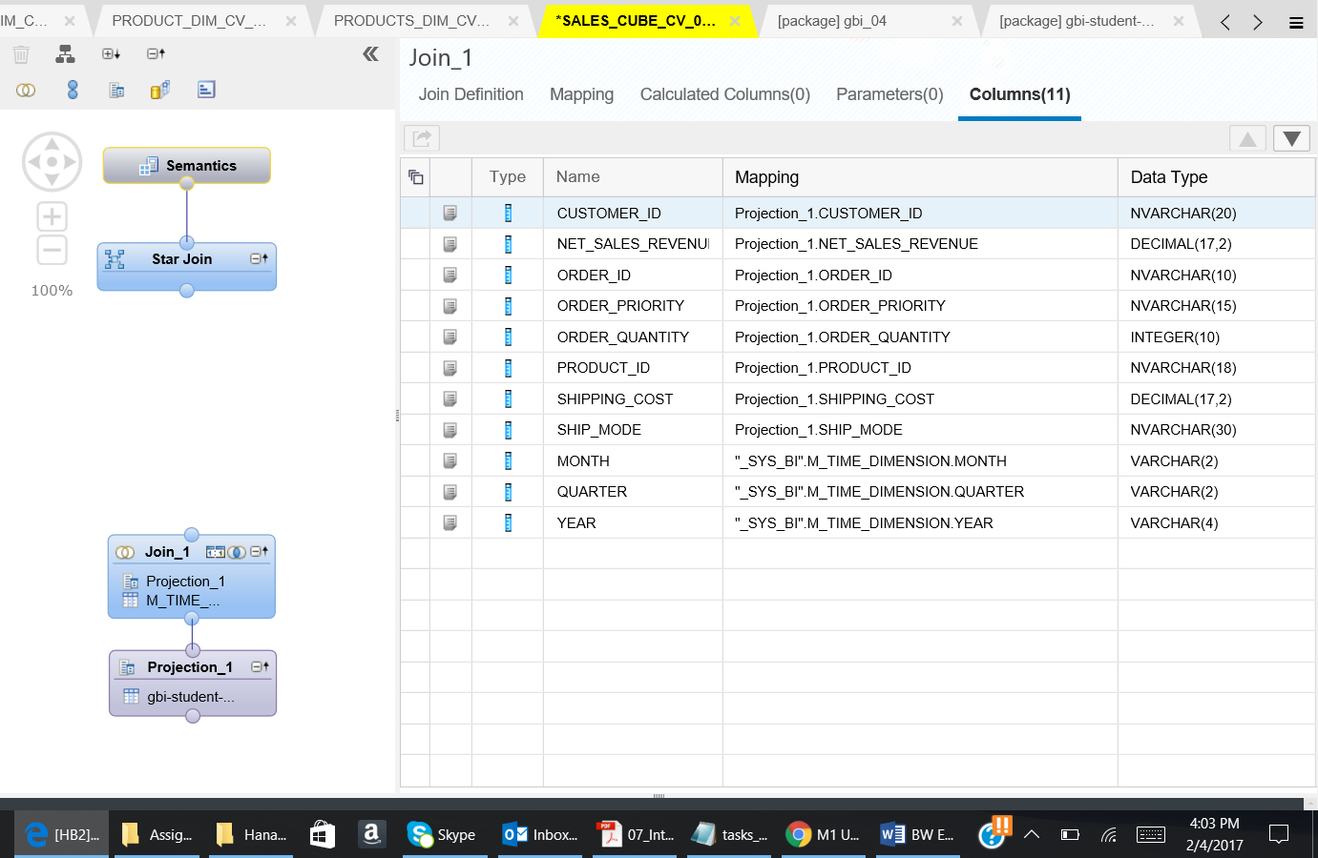

Paste the screen shot of your Column tab. The screenshot should include the date and time when the screen is taken.

1. Now generate the Time Data.

Click on the icon on the top left corner. Go to Tools and click on Generate Time Data.

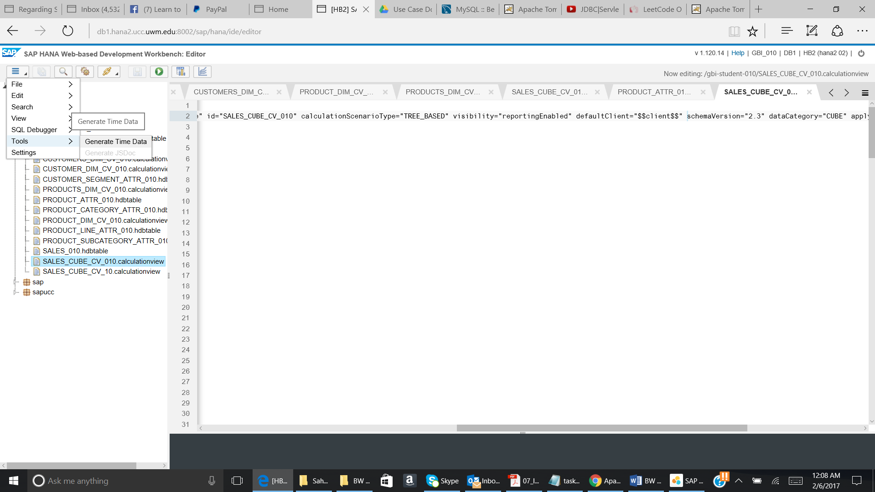

The pop up will appear. Give the details as given below.

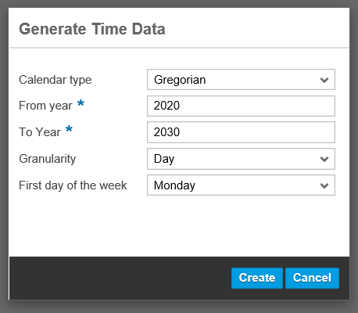

Click on Create.

1. Now connect the Join_1 to the Star Join.

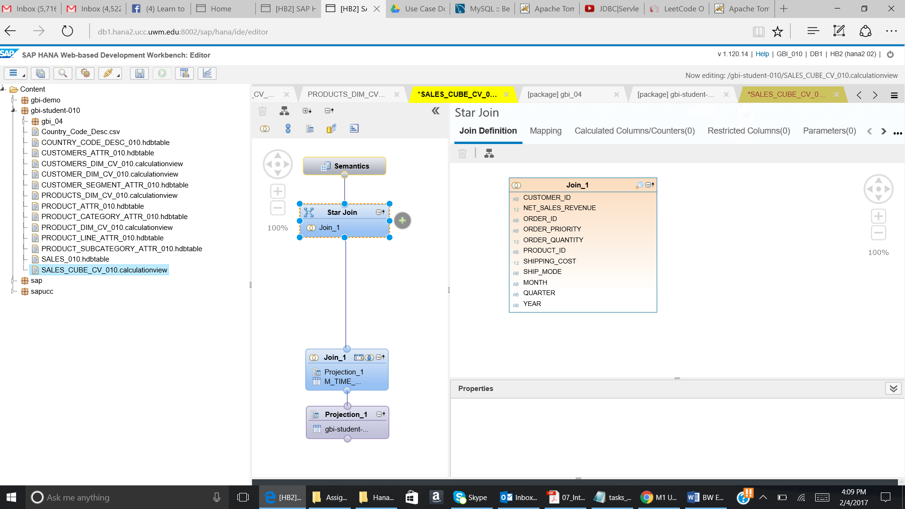

Click on the Star Join. The + sign will appear. Click on the + sign and add Product and Customer dimension which you have created in the Assignment 5.

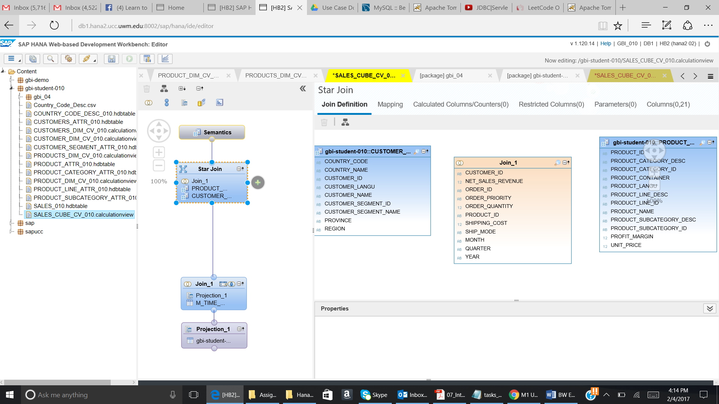

Drag the Customer_Id from the Join_1 to the Customer_Id of Customer_Dim_Cv_YYY.

Drag the Product_Id from the Join_1 to the Product_Id of Product_Dim_Cv_YYY.

**The Joins are Referential Join and the Cardinality box should be empty (system will chose the exact cardinality according to the data in this case)**

The below given screenshot will be shown:

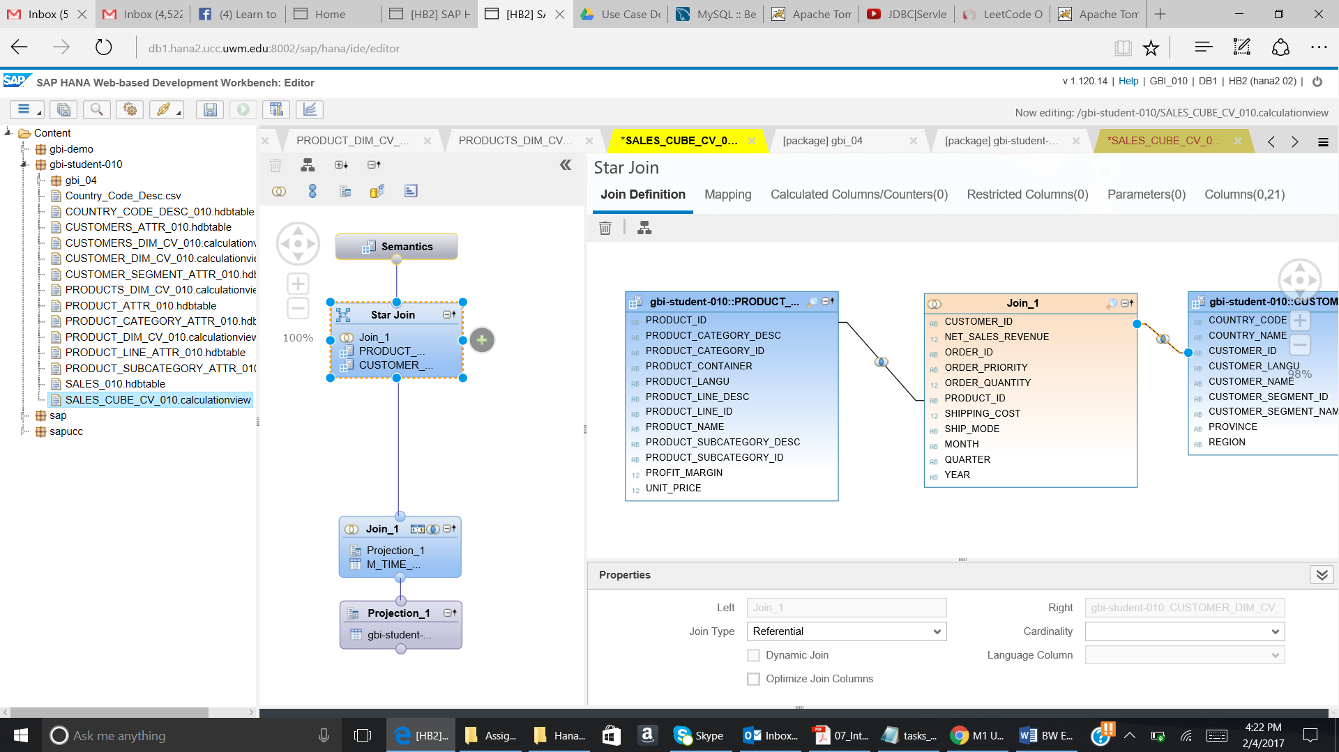

Go to the Mapping tab and then perform the below given mapping:

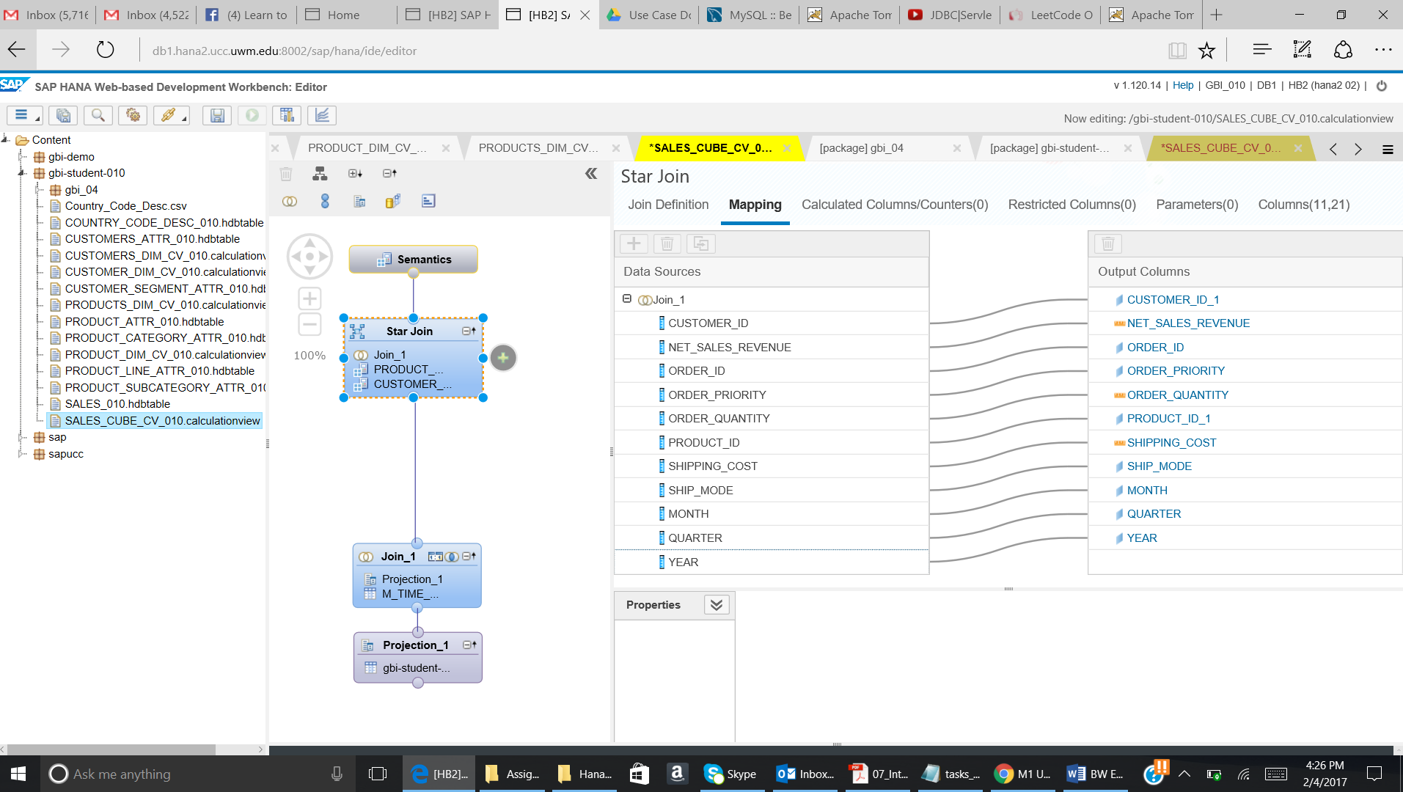

Click on Columns tab. The below given screenshot will come:

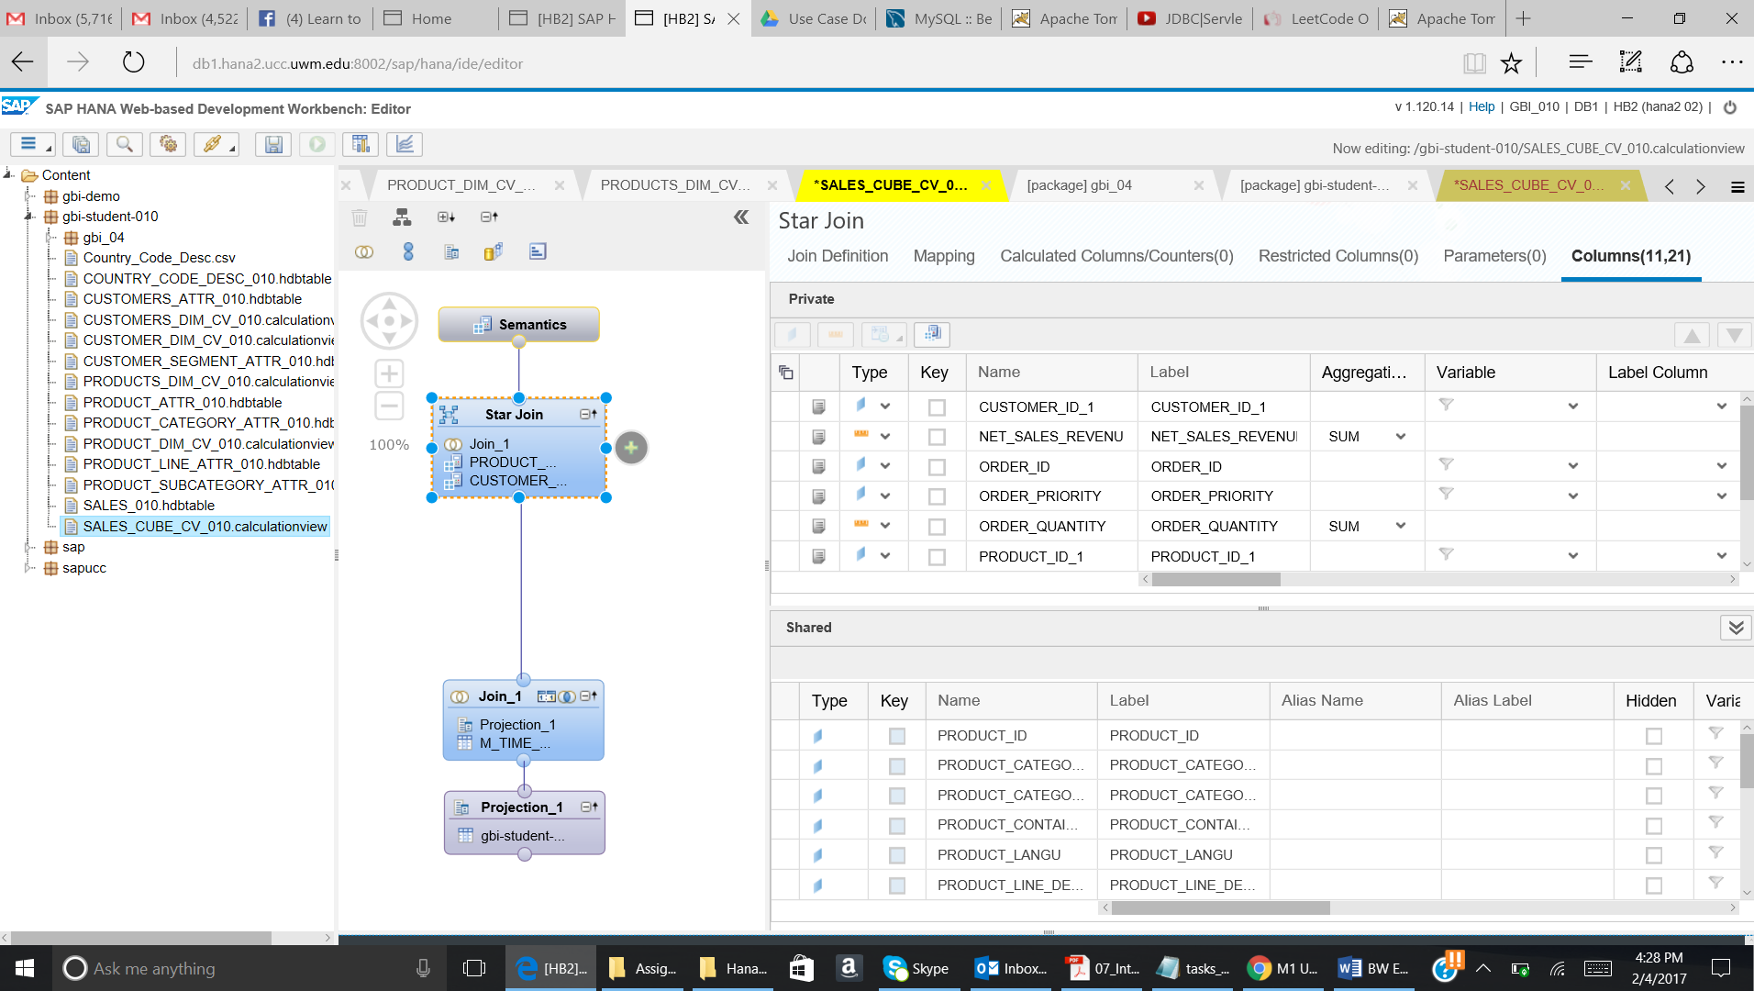

Click on Semantics. The below given screenshot will come:

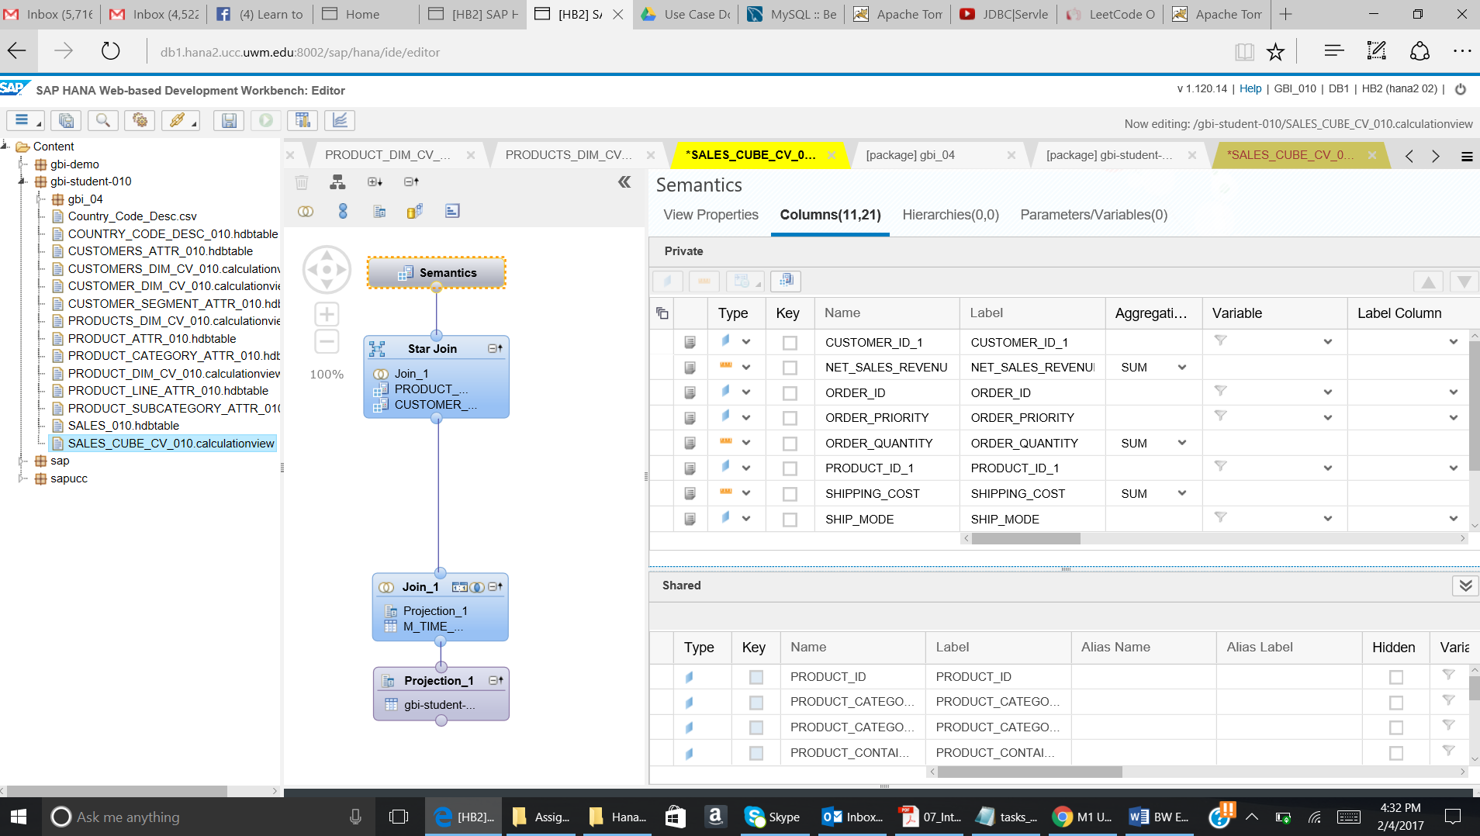

**Ensure the Aggregations for the “Measures” are SUM in the Star Join and the Semantics.**

Paste the screenshot of the screen you get after clicking on the Semantics. The screenshot should include date and time when the screenshot is taken.

* 1. Add the discount price as calculated measure to the output structure of your view

Click on the Star Join and go to the Calculated Columns tab.

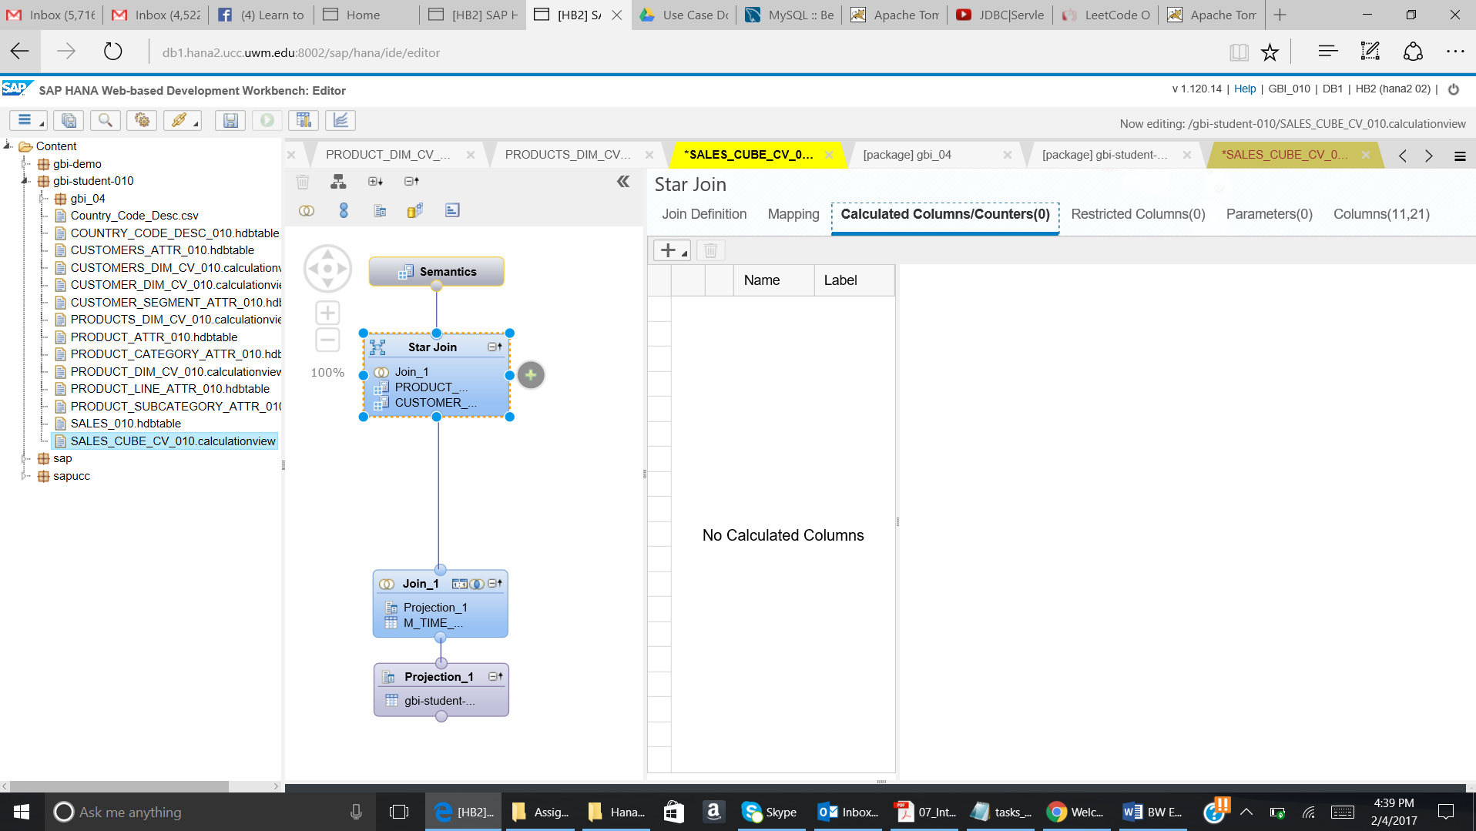

Click on the + sign and then select Calculated column.

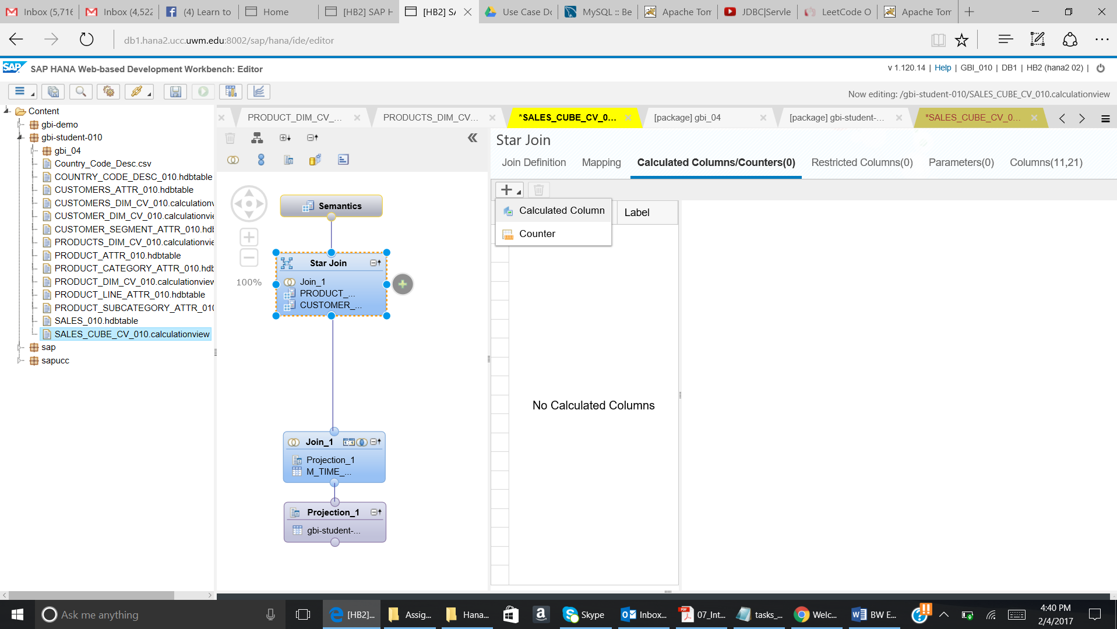

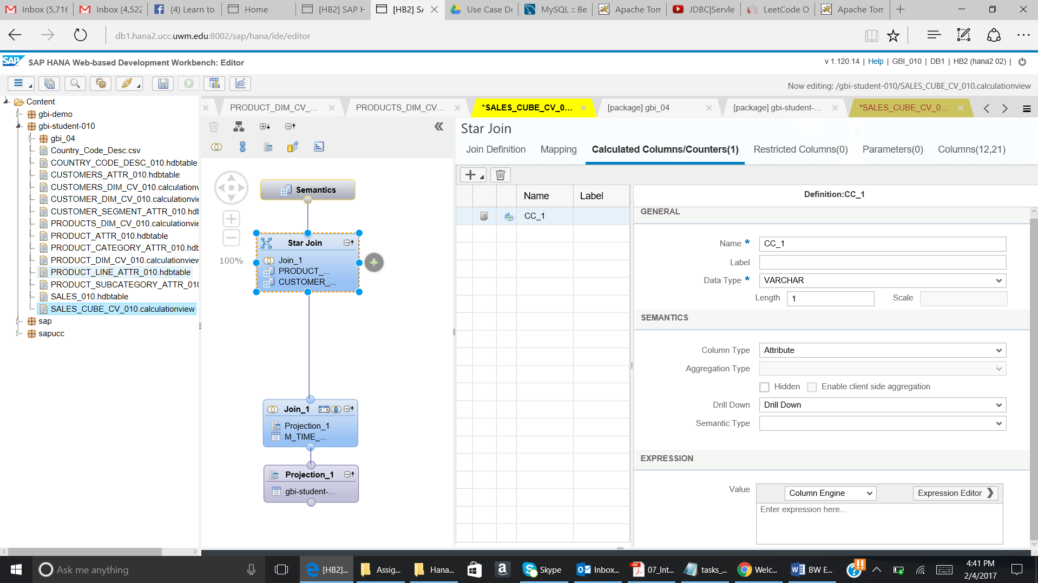

Use following details to create the calculated measure:

Name: DISCOUNT

Description: Discount

DataType : Decimal

Length : 17 Scale : 2

Column Type : Measure

Check Enable ClientSide Aggregation

Aggregation Type : SUM

Formula: (float("UNIT_PRICE")*"ORDER_QUANTITY")-("NET_SALES_REVENUE"-"SHIPPING_COST")

[Please Note: It is recommended if you use Expression Editor.]

Regarding the currency, enter following details:

Measure (Column) Semantic Type: Amount with Currency

Currency: Fixed Attribute *USD*.

The screenshot will look like below:

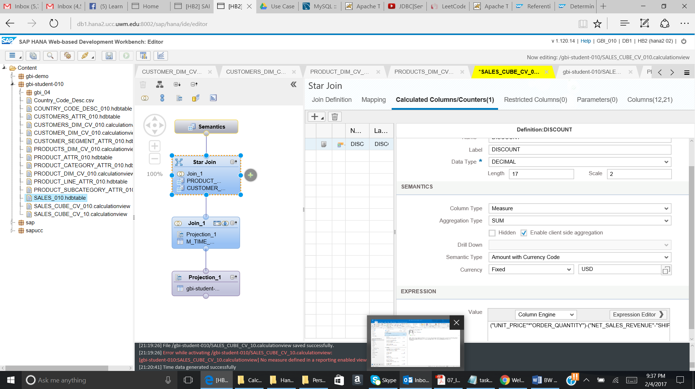

* 1. Add the profit as calculated measure to the output structure of your view

Use following details to create the calculated measure:

Name: PROFIT

Description: Profit

DataType : Decimal

Length : 17 Scale : 2

Column Type : Measure

Check Enable ClientSide Aggregation

Aggregation Type : SUM

Formula: “PROFIT_MARGIN”*("NET_SALES_REVENUE"-"SHIPPING_COST")

[Please Note: It is recommended if you use Expression Editor.]

Regarding the currency, enter following details:

Measure (Column) Semantic Type: Amount with Currency

Currency: Fixed Attribute *USD*.

The screenshot will look like below:

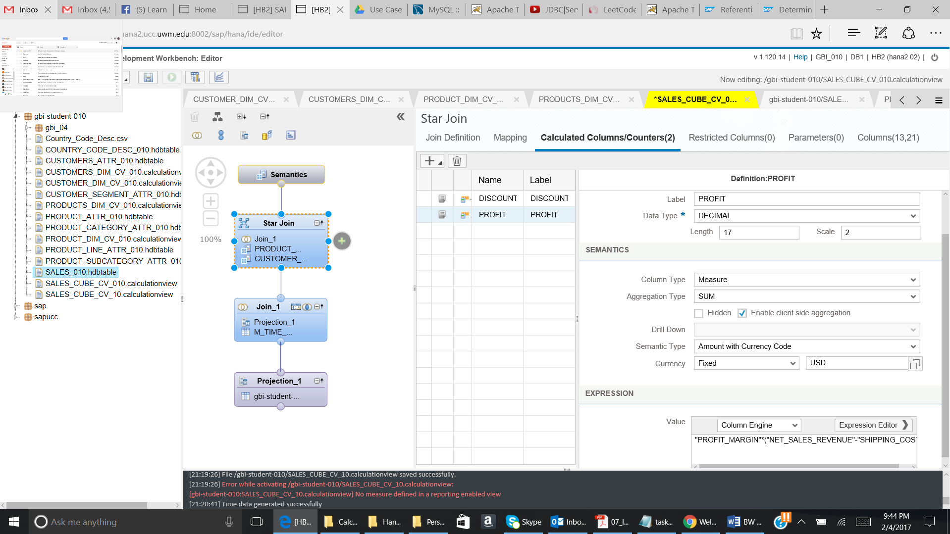

* 1. Save, validate and activate the view.

1. Press Save and Validate.

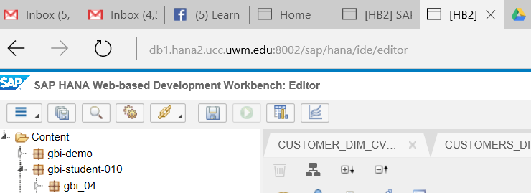

Check the Job Log. In case of an error, the job is highlighted in red.



Paste your success message below:

**After this, ensure the formula you have entered is still there in your calculated columns and have been saved properly.**

* 1. Go to column tab and paste the screenshot of all the columns

--------------------------------------------------------------------------------------------

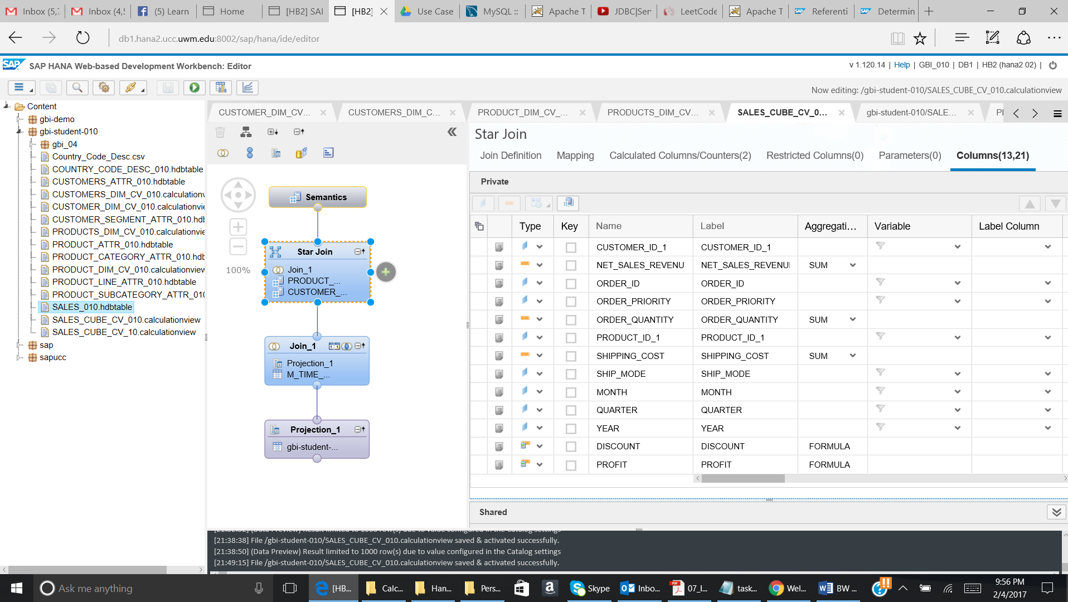

* 1. Click on the green run button as given below:

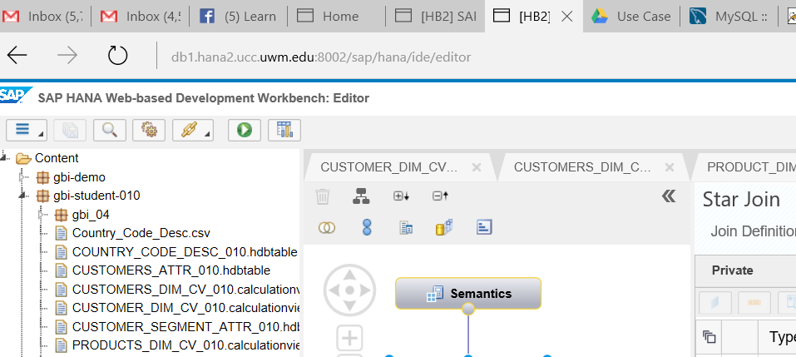

Question:

Paste the screenshot of the data generated__________________

1. Now we will open SAP Lumira desktop application to do analysis on cube we created.
2. First of all, in order to visualize the cube in SAP Lumira, we will do a workaround. This workaround is specifically for this version of SAP HANA. So it will not be needed in the future releases of SAP HANA.

Right click on cube which we created and then select Open with text editor.

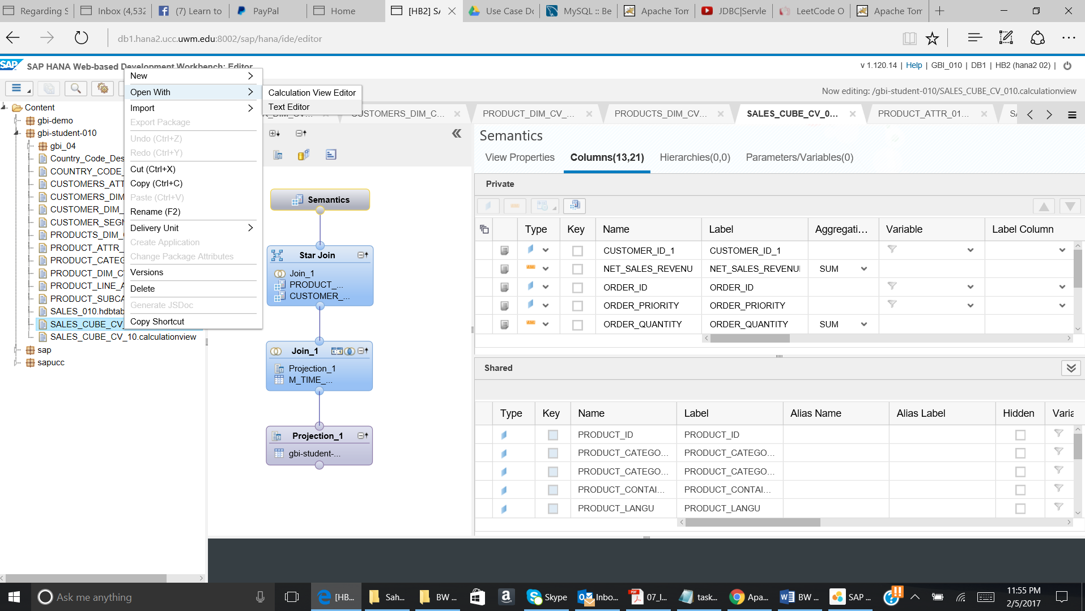

Go to second line and delete the expression dimensionType=”STANDARD”

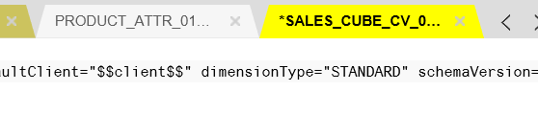

Save the View.

1. We will use SAP Lumira for Analysis of cube.

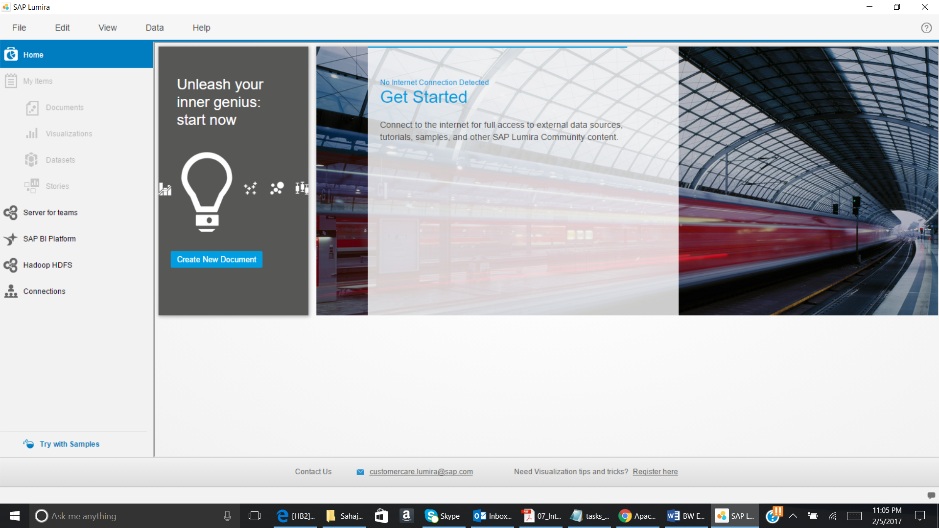

Go to File and then click on New.

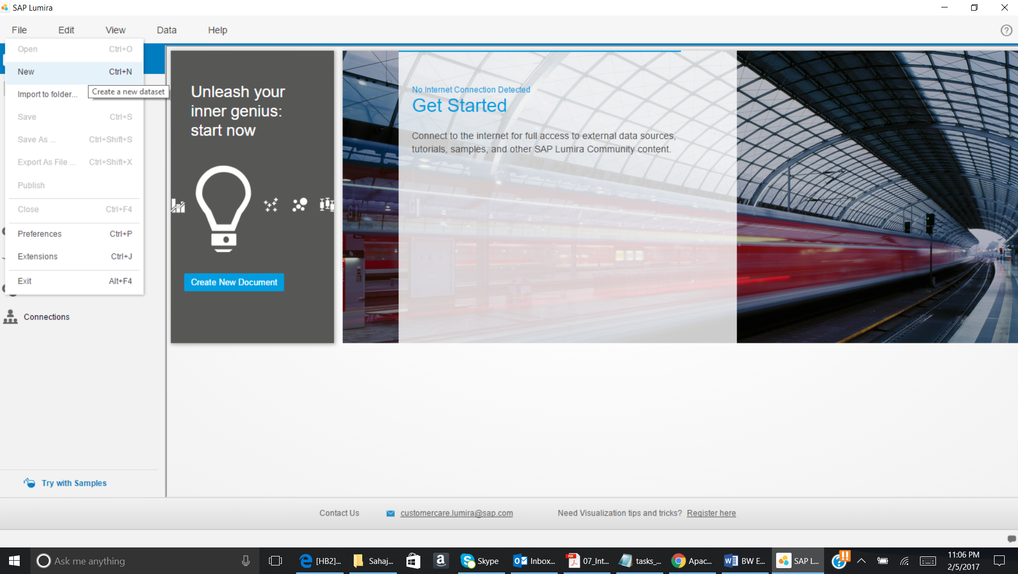

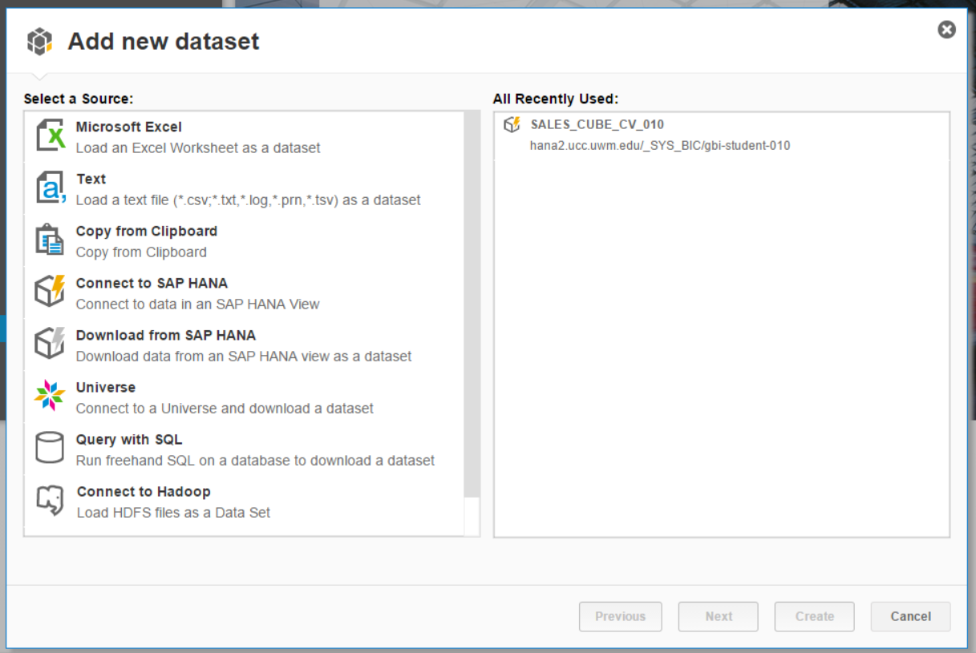

Select Connect to SAP HANA and click on Next.

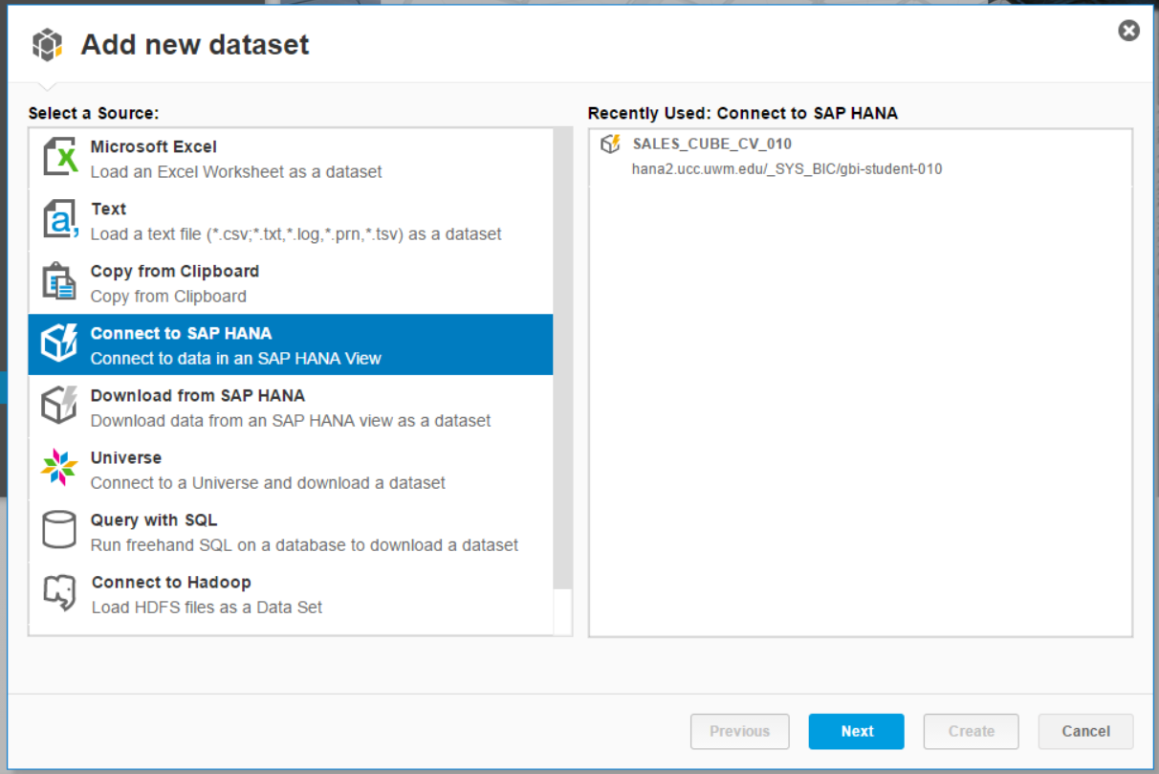

Now give the below given information:

Connect To: HANA

Server: hana2.ucc.uwm.edu

Instance: 30259

Provide your SAP HANA UserId and Password.

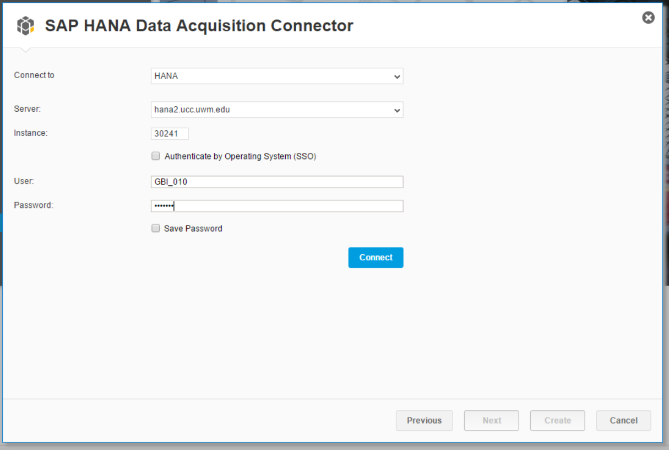

Now click on connect.

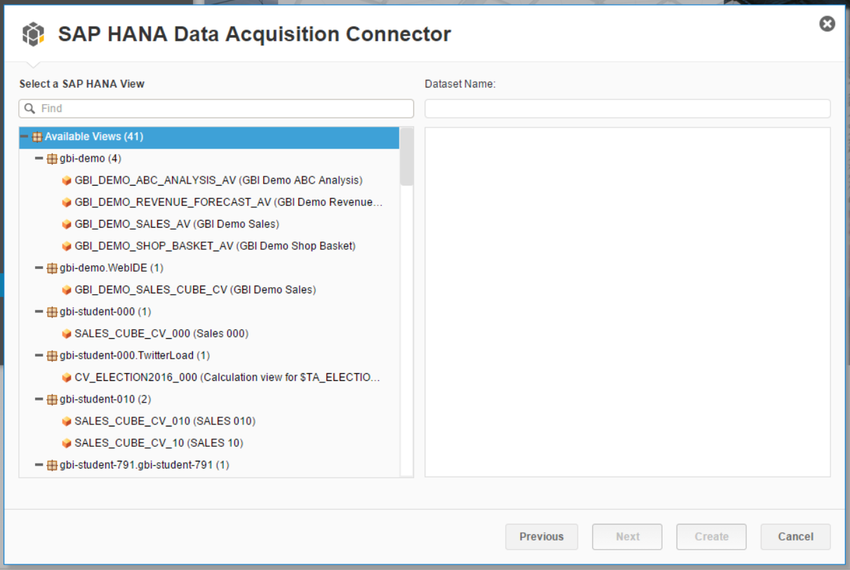

Now search for the cube which you have created.

SALES_CUBE_CV_YYY

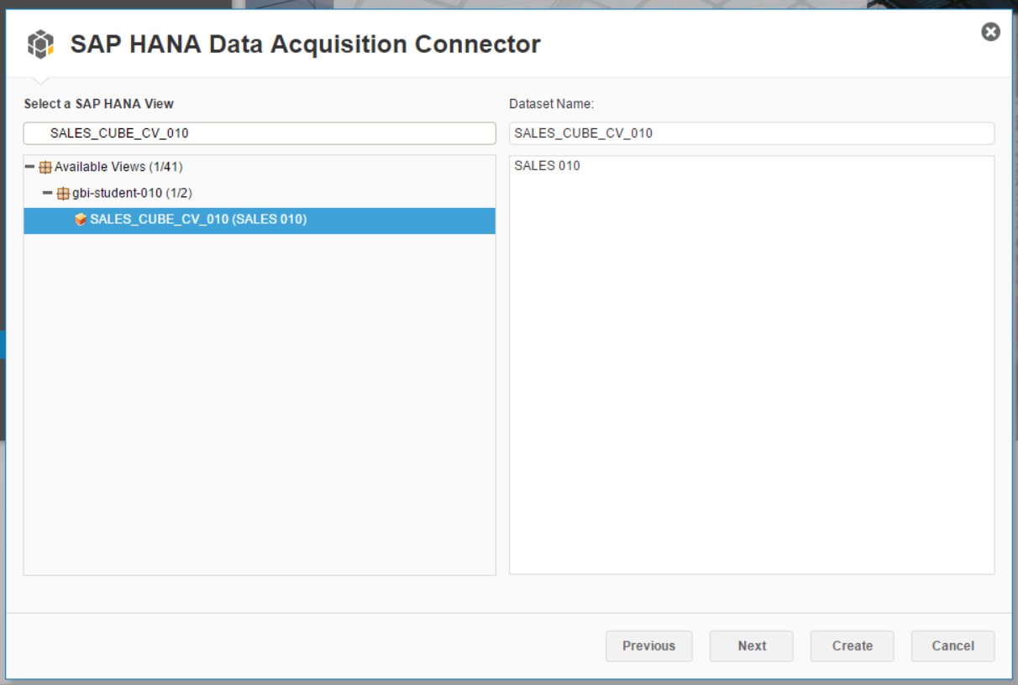

Click on Next

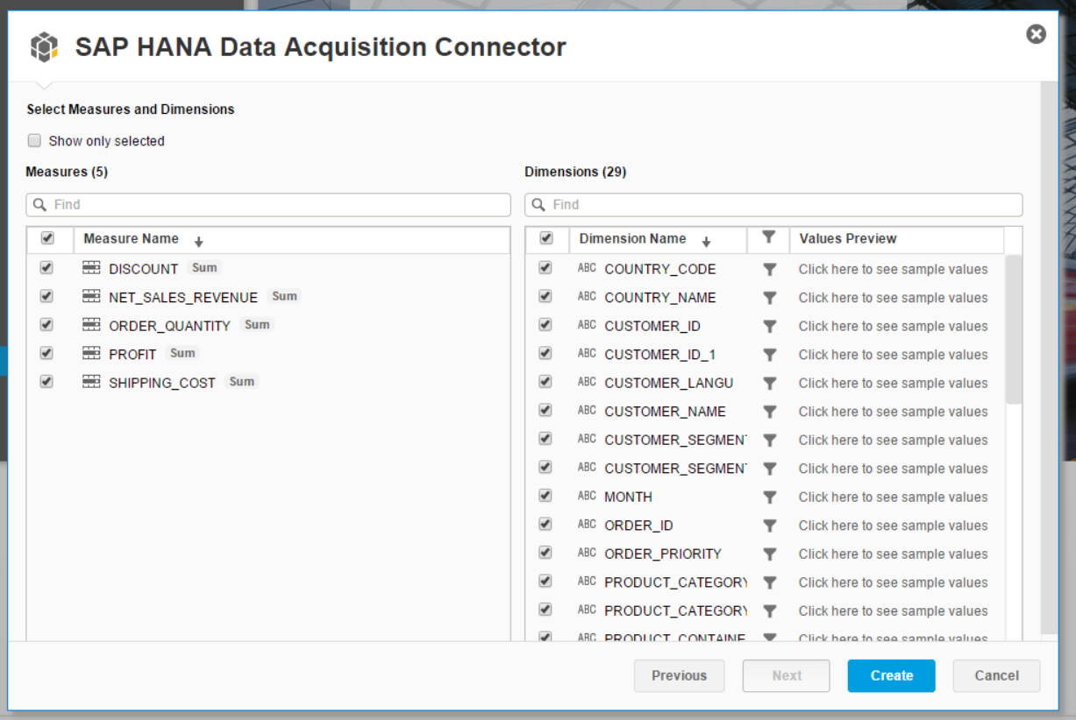

Click on Create. The below given screen will come.

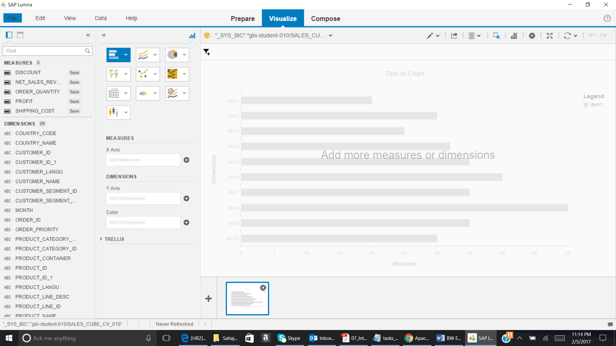

1. Drag & drop CUSTOMER__NAME in Y (Dimension) axis and NET_SALES_REVENUE in X (Measure) axis.

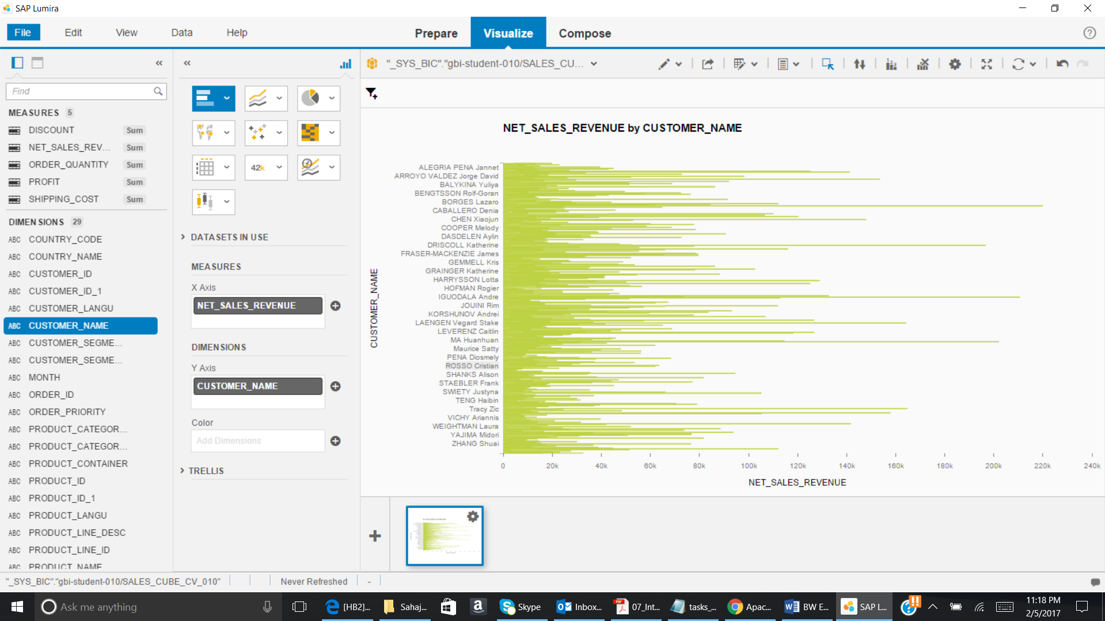

1. Click on Filter icon.

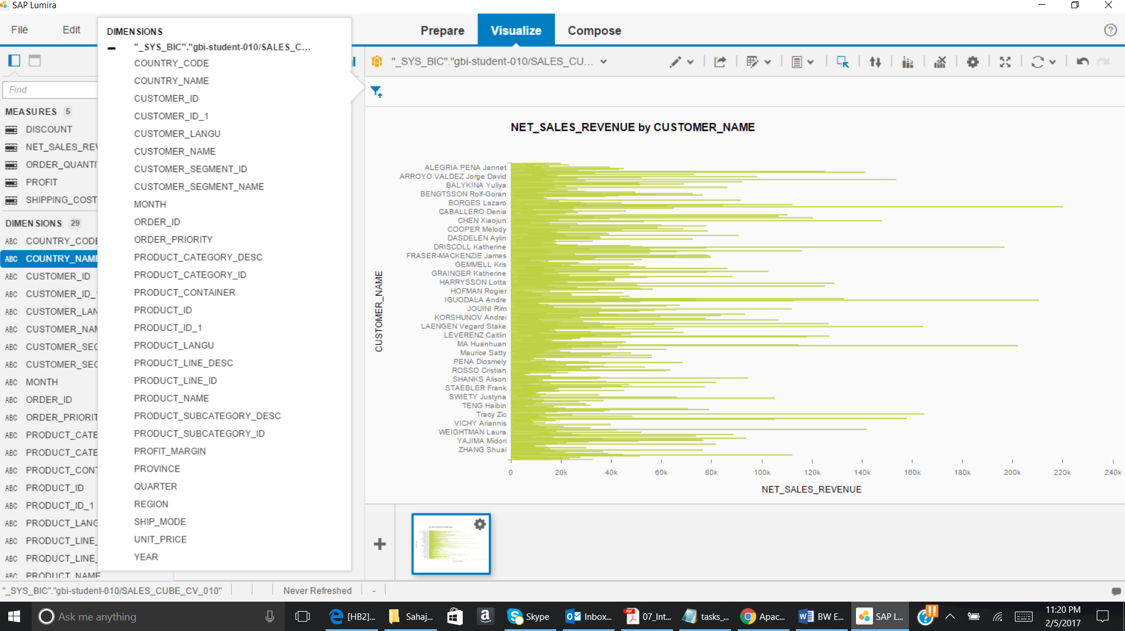

Now Select COUNTRY_NAME

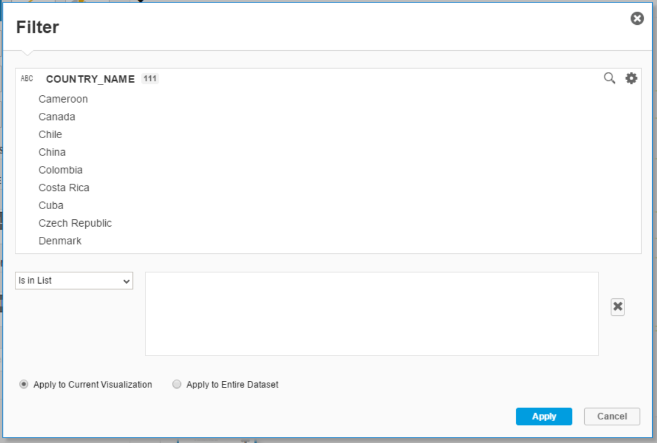

Select country as COSTA RICA and click on Apply.

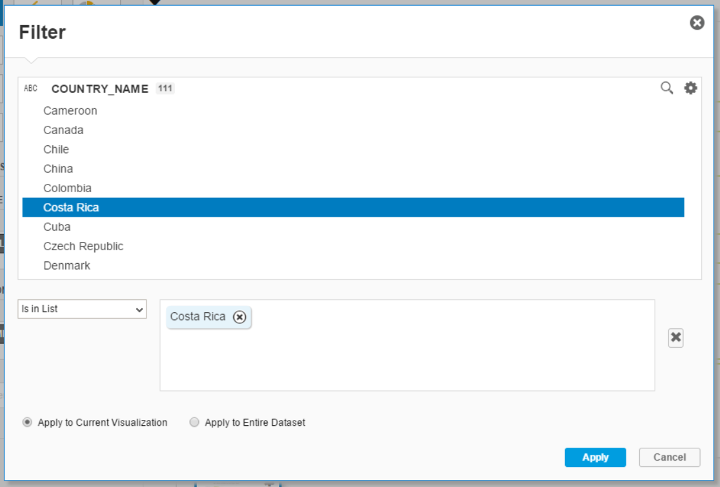

The below given screenshot will come:

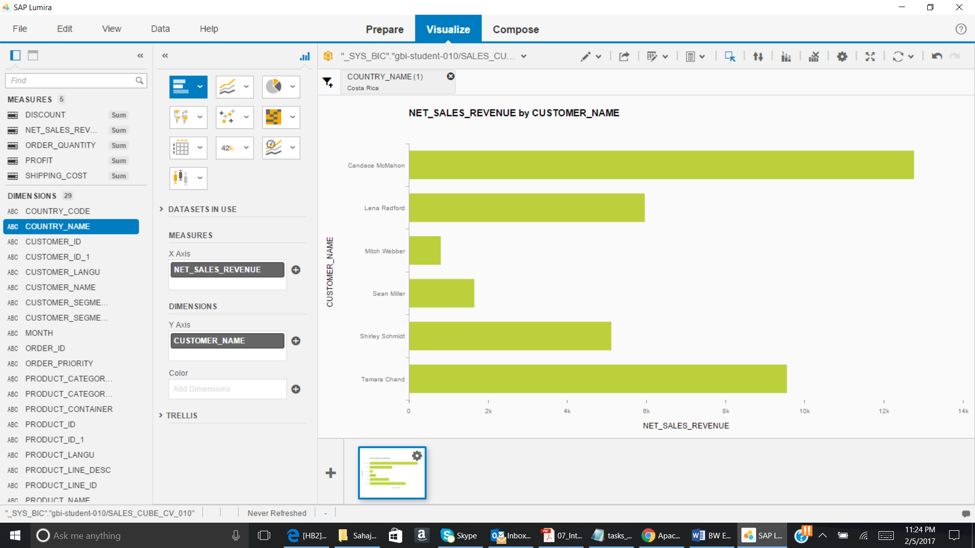

Again click on Filter icon and click on YEAR. Select year as 2025.

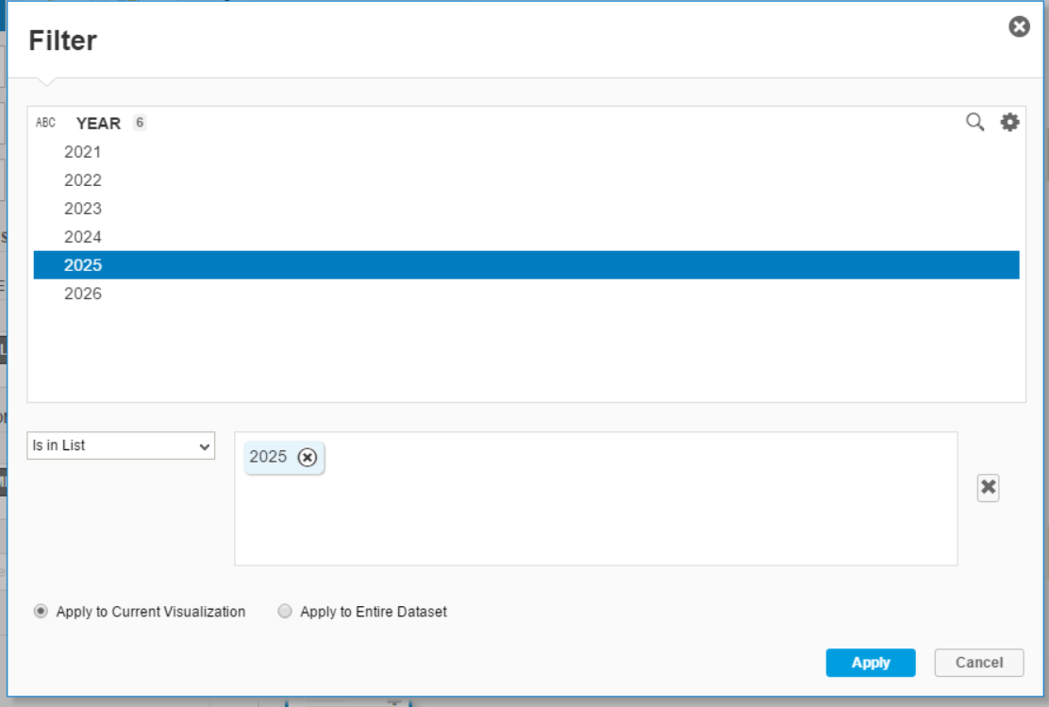

Click on Apply. The below given screenshot will come:

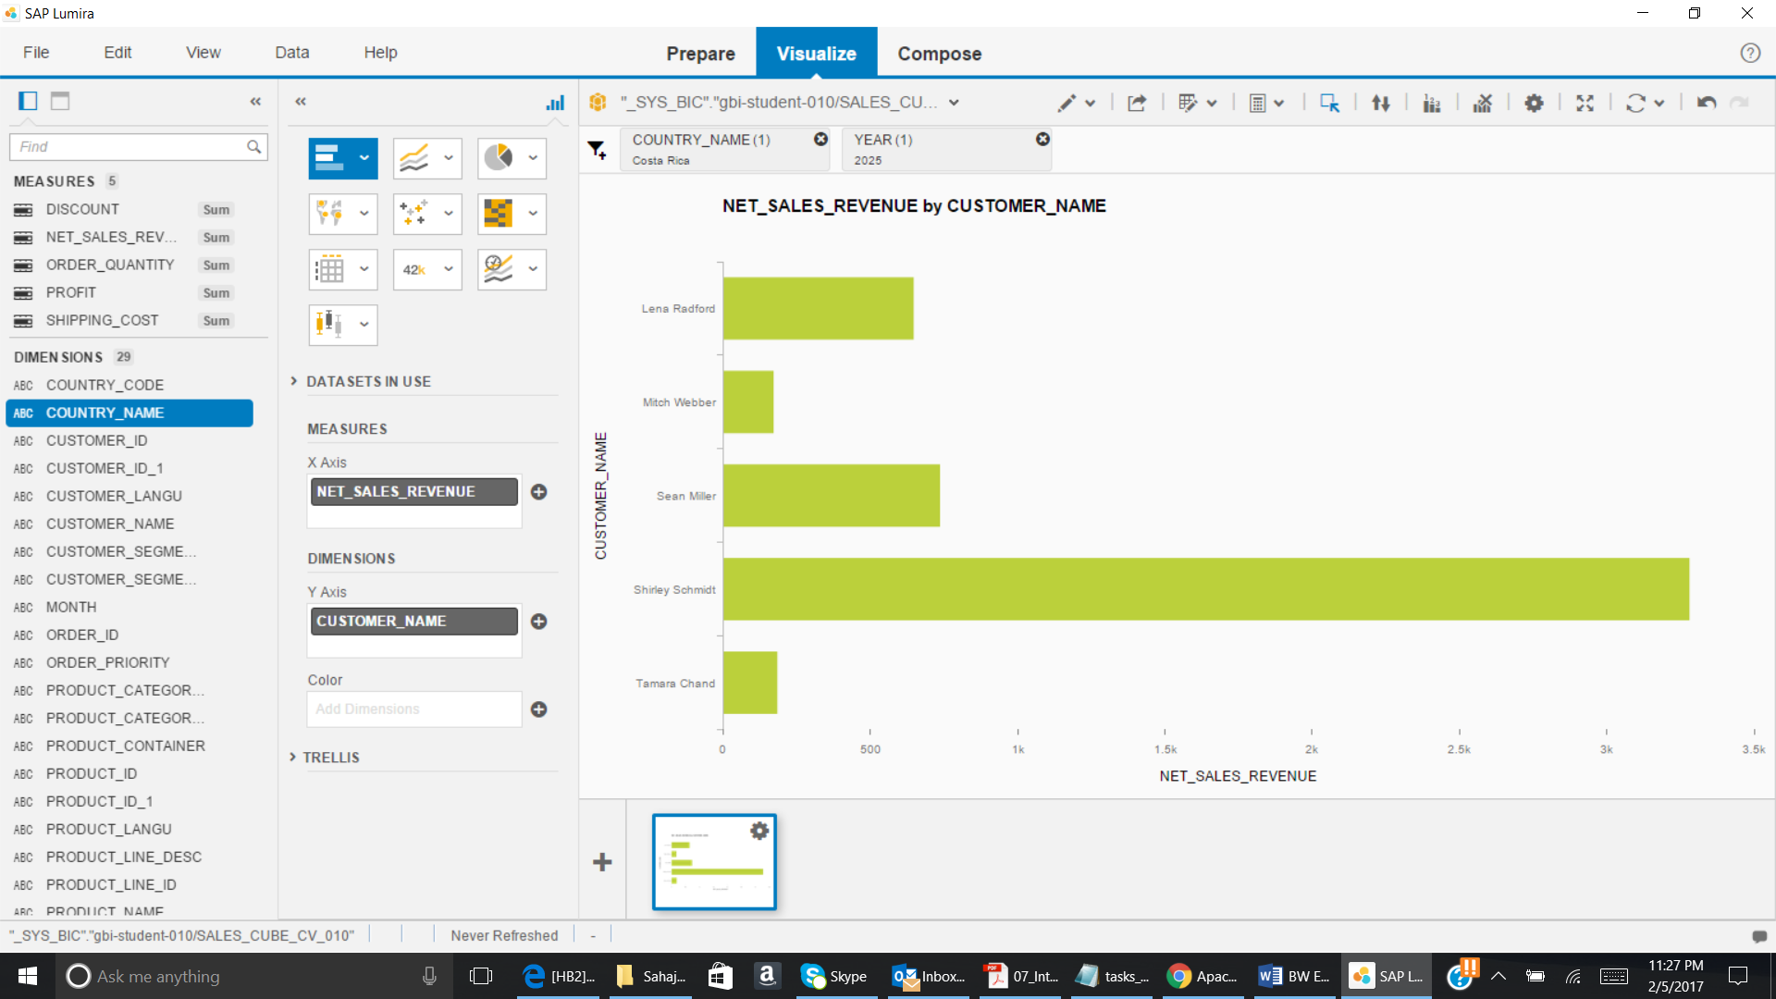

Now click on NET_SALES_REVENUE and then click on small settings icon.

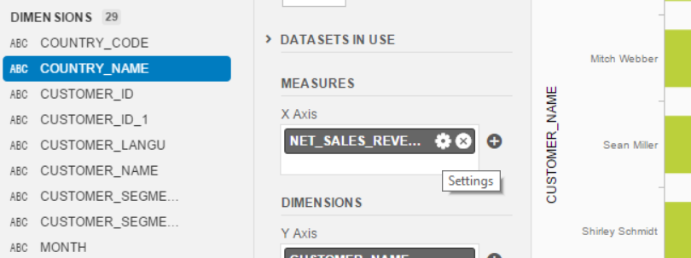

Select Sort Ascending

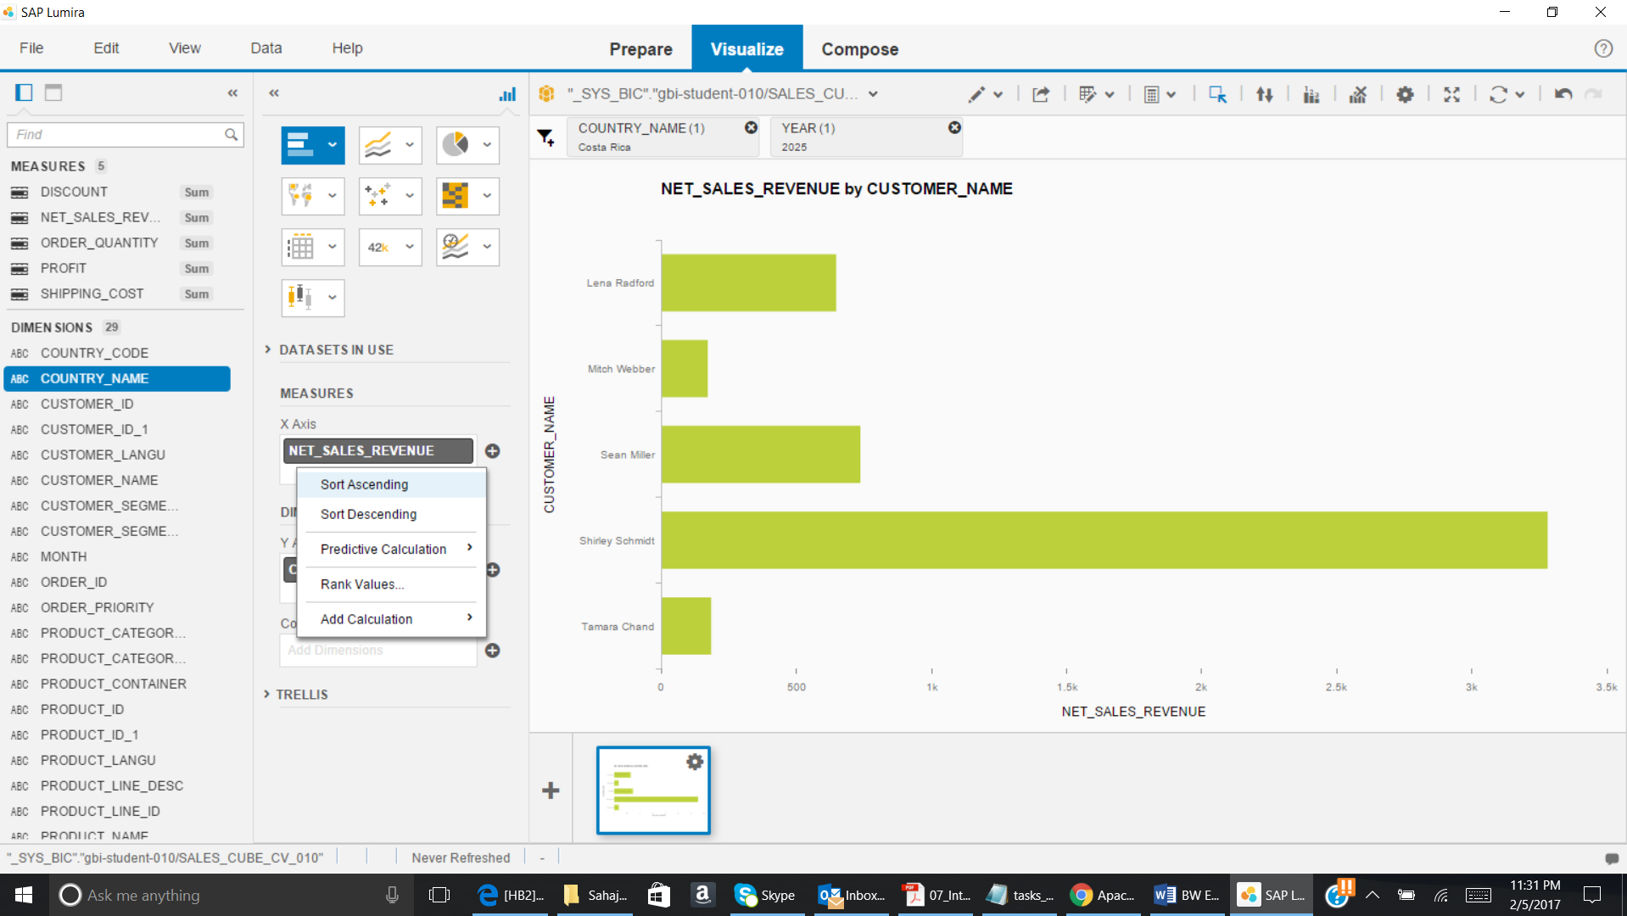

The below given screenshot will come:

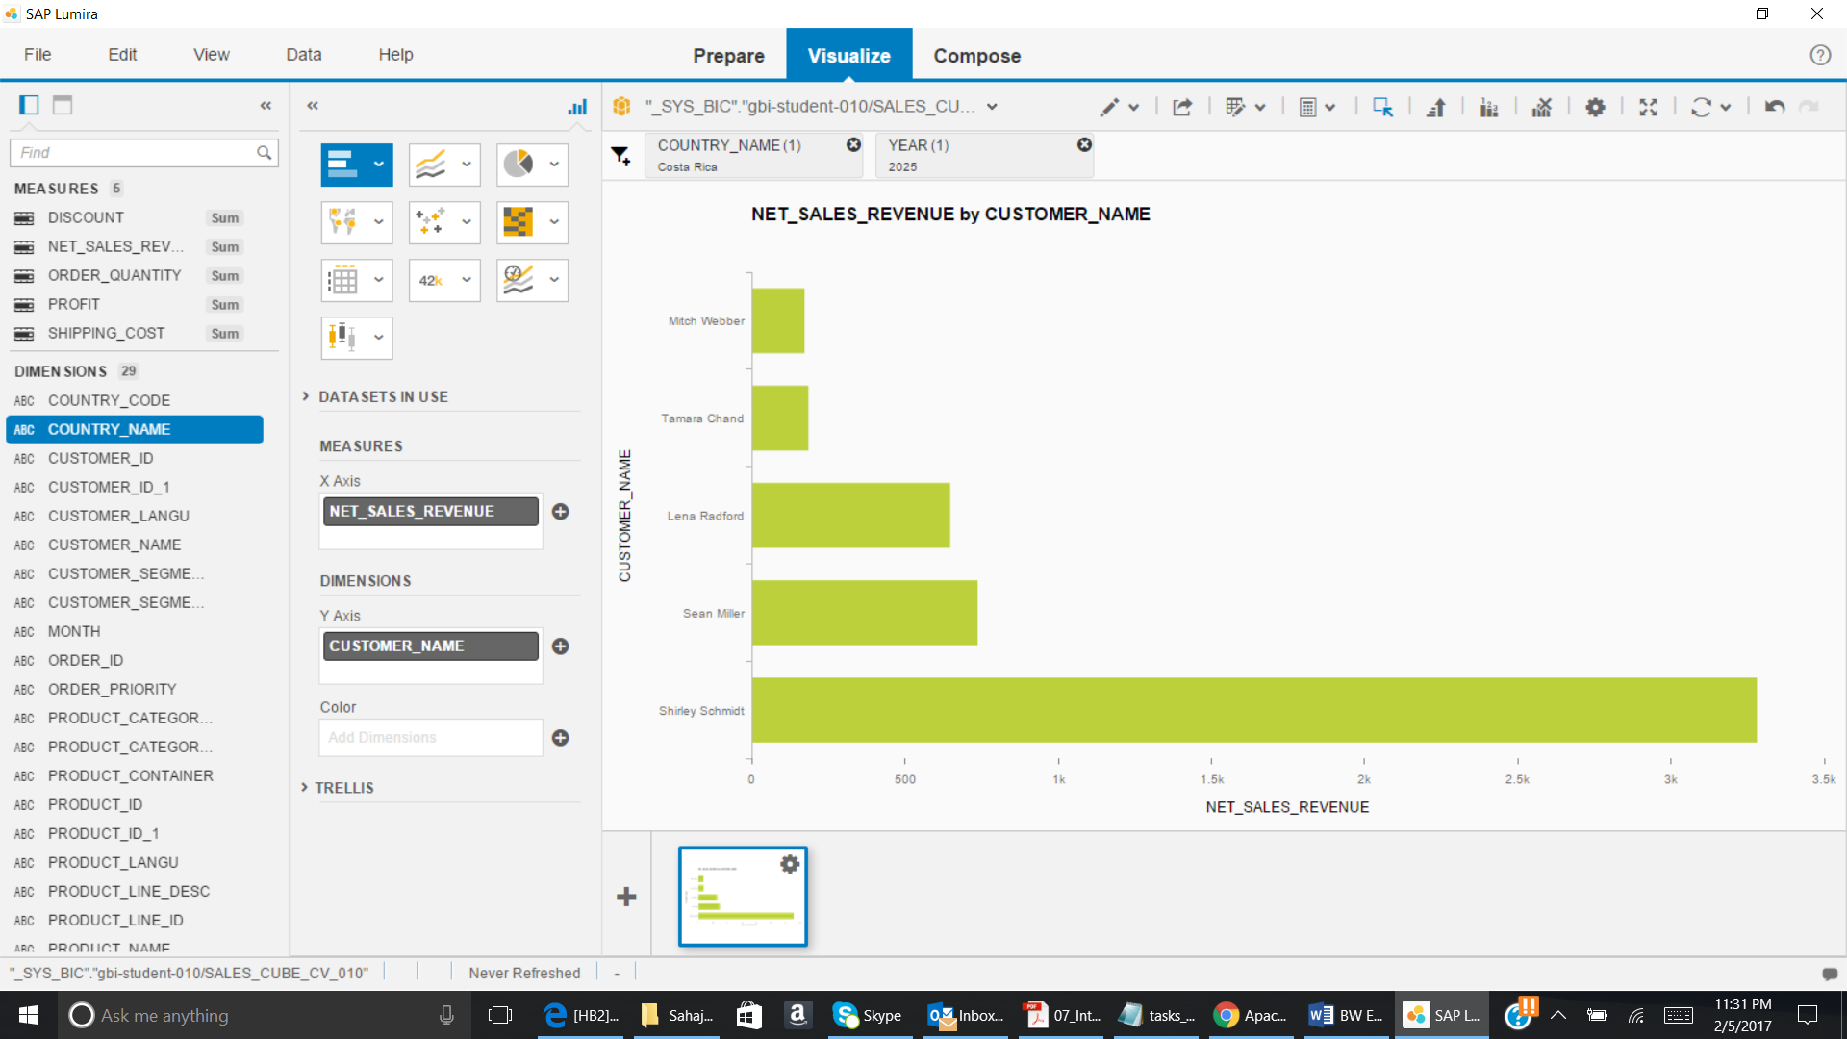

Paste the screenshot:

1. Remove CUSTOMER_NAME from Y axis. Drag & drop CUSTOMER_SEGMENT_NAME in Y axis. Now filter for COUNTRY_NAME as ‘*India’ and YEAR as ‘2023’.*

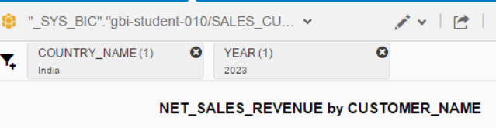

Now click on Pie Chart.

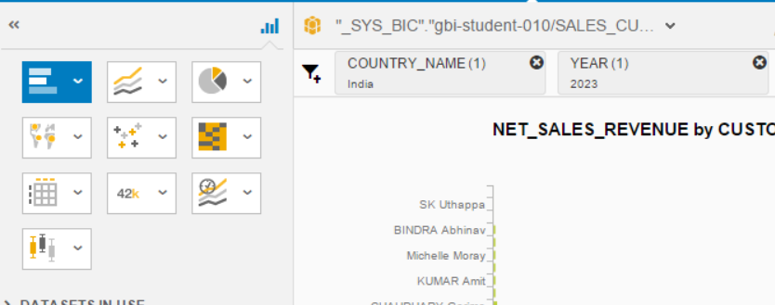

Paste the screenshot:

1. Remove all the filters. Also, remove all the attributes and measures from Y axis and X axis. Drag & drop YEAR in Y axis. Drag & drop NET_SALES_REVENUE AND PROFIT in X axis. Select a line chart.

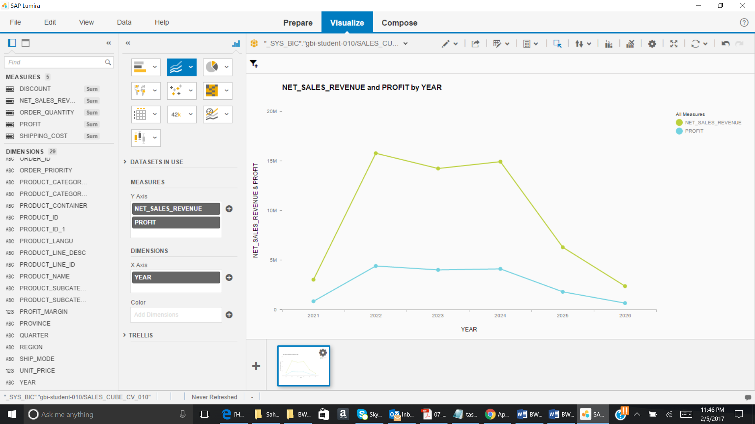

Click on Filter and add COUNTRY_NAME to filters. Then select *‘United States’* and click on Apply.

Paste the screenshot: